Development of a Multichannel Modular Universal Biopotential Amplifier Trainer

A Project Submitted

By

|  |  |
| --- | --- |
| 1. Tushar, Fakrul Islam | **ID: 13-23244-1** |
| 1. Rokan, MD. Amirul Islam | **ID: 13-23295-1** |
| 1. Chowdhury, Rupu | **ID: 13-23143-1** |



Under the Supervision of

Saiful Islam Khan

Faculty

American International University - Bangladesh

**Department of**

**Electrical and Electronic Engineering**

**Faculty of Engineering**

Summer **Semester 2015-2016,**

**August, 2016**

**American International University - Bangladesh**

**Development of a Multichannel Modular Universal Biopotential Amplifier Trainer**

A project submitted to the Electrical and Electronic Engineering Department of the Engineering Faculty, American International University - Bangladesh (AIUB) in partial fulfillment of the requirements for the degree of Bachelor of Science in Electrical and Electronic Engineering.

|  |  |
| --- | --- |
| 1. Tushar, Fakrul Islam | **ID: 13-23244-1** |
| 1. Rokan, MD. Amirul Islam | **ID: 13-23295-1** |
| 1. Chowdhury, Rupu | **ID: 13-23143-1** |

**Department of**

**Electrical and Electronic Engineering**

**Faculty of Engineering**

Summer **Semester 2015-2016,**

**August, 2016**



**American International University - Bangladesh**

DECLARATION

This is to certify that this project is our original work. No part of this work has been submitted elsewhere partially or fully for the award of any other degree or diploma. Any material reproduced in this project has been properly acknowledged.

Students’ names & Signatures

1. Tushar, Fakrul Islam

_ _ _ _ _ _ _ _ _ _ _ _ _ _ _ _ _ _ _

1. Rokan, MD. Amirul Islam

_ _ _ _ _ _ _ _ _ _ _ _ _ _ _ _ _ _ _ _

1. Chowdhury, Rupu

_ _ _ _ _ _ _ _ _ _ _ _ _ _ _ _ _ _ _ _

APPROVAL

The Project titled “Development of a Multichannel Modular Universal Biopotential Amplifier Trainer” has been submitted to the following respected members of the Board of Examiners of the Faculty of Engineering in partial fulfillment of the requirements for the **degree of Bachelor of Electrical and Electronic Engineering** on August, 2016 by the following students and has been accepted as satisfactory.

|  |  |
| --- | --- |
| 1. Tushar, Fakrul Islam | **ID: 13-23244-1** |
| 1. Rokan, MD. Amirul Islam | **ID: 13-23295-1** |
| 1. Chowdhury, Rupu | **ID: 13-23143-1** |

_ _ _ _ _ _ _ _ _ _ _ _ _ _ _ _ _ _

Supervisor

Saiful Islam Khan

Faculty

Faculty of Engineering

American International University-Bangladesh

_ _ _ _ _ _ _ _ _ _ _ _ _ _ _ _ _ _

Prof. Dr. ABM Siddique Hossain

Dean

Faculty of Engineering

American International University-Bangladesh

_ _ _ _ _ _ _ _ _ _ _ _ _ _ _ _ _

External Supervisor

Chowdhury Akram Hossain

Assistant Professor

Faculty of Engineering

American International University-Bangladesh

_ _ _ _ _ _ _ _ _ _ _ _ _ _ _ _ _ _

Dr. Carmen Z. Lamagna

Vice Chancellor

American International University-Bangladesh

ACKNOWLEDGEMENT

In First we would like to express our heartiest gratefulness to the Almighty Allah to give encourages to us all time. Then we would like to express our deepest gratitude to our supervisor **Saiful Islam Khan**, Lecturer, Faculty of Engineering, American International University-Bangladesh (AIUB), for his skilled guidance, assistance and endless support during this project. He gave us proper directions and advises that helps us a lot to overcome the difficulties that we encountered during the implementation of our project. We are also thankful to our external **Chowdhury Akram Hossain,** Assistant Professor, Faculty of Engineering, American International University-Bangladesh (AIUB), for his assistance and guidelines in reviewing the project. We would like to express our gratitude to **Prof.** **Dr. ABM Siddique Hossain**, Dean, Faculty of Engineering, American International University-Bangladesh (AIUB), for his support and guidelines towards our undergraduate activities. In the reference section of this book, we have mentioned the names and authors of the papers and information sources without which this project would have not been possible, and our gratitude reaches out to all those authors.

|  |
| --- |
| 1. Tushar, Fakrul Islam |
| 1. Rokan, MD. Amirul Islam |
| 1. Chowdhury, Rupu |
|  |

**TABLE OF CONTENTS**

DECLARATION i

APPROVAL ii

ACKNOWLEDGEMENT iii

LIST OF FIGURES viii

ABSTRACT xii

Chapter 1 1

Introduction 1

1.1. Introduction 1

1.2. Motivation and Objective 2

1.2.1. Primary Objective 2

1.2.2. Secondary Objective 2

1.3. Literature Overview 2

1.3.1. Bio-potential 2

1.3.1.1. Electrocardiogram (ECG) 2

1.3.1.2. Electroencephalogram (EEG) 3

1.3.1.3. Electromyography (EMG) 3

1.3.2. Bioamplifier 3

1.3.2.1. Instrumentation amplifier 3

1.3.2.2. Non-inverting Amplifier 3

1.3.2.3. Right-Leg Driven Circuit 4

1.3.2.4. Filter 4

1.3.2.5. Notch Filter 4

1.3.2.6. Low pass filter 4

1.3.2.7. High pass filter 4

1.3.3. Data Acquisition 5

1.3.3.1. Arduino 5

1.3.3.2. MATLAB 5

1.4. Block Diagram of the Project 6

1.5. Future Scope of this Project 7

Chapter 2 8

Bioamplifier 8

2.1. Introduction 8

2.2. Biopotential 8

2.2.1. Electrocardiogram (ECG) 8

2.2.1.1. Heart Conduction System 8

2.2.1.2. About Electrocardiography (ECG) 9

2.2.1.3. Historical Background of ECG 10

2.2.1.4. Action potential in Cell 10

2.2.1.5. Characteristics of ECG 11

2.2.1.6. Lead System of ECG 12

2.2.2. Electroencephalogram (EEG) 14

2.2.2.1. Historical Background of EEG 14

2.2.2.2. The Behavior of the EEG signal 15

2.2.2.3. The Basic Principle of EEG diagnosis 16

2.2.2.4. EEG Measuring Method 17

2.2.3. Electromyography (EMG) 18

2.2.3.1. Historical Background of EMG 18

2.2.3.2. Present and Future Use of EMG 19

2.2.3.3. Generation Of EMG Signal 19

2.2.3.4. EMG recording 20

2.3. Bio-Amplifier 22

2.3.1. History of Bio-Amplifier 22

2.3.2. Bio-amplifier for ECG 23

2.3.3. Bio-amplifier for EEG 23

2.3.4. Bio-amplifier for EMG 24

2.4. Background Studies 25

2.4.1. Tech Companies Modules 25

2.4.1.1. BIOPAC 25

2.4.1.2. BiBeat 26

2.4.1.3. OpenBCI 28

2.4.1.4. Mega Electronics Ltd 29

2.5. Summary 30

Chapter 3 31

Instrumentation 31

3.1. Introduction 31

3.2. Electrocardiogram (ECG) Module 31

3.2.1. Equipmemts 32

3.2.2. Designing the Circuit 32

3.2.3. Right-Leg Driven Circuit 32

3.2.4. Instrumentation Amplifier 33

3.2.5. Non-Inverting Amplifier 34

3.2.6. Notch Filter 34

3.3. Electroencephalogram (EEG) Module 35

3.3.1. Equipment 36

3.3.2. Design the Circuit 36

3.3.3. Right-Leg Driven Circuit 36

3.3.4. Instrumentation Amplifier 36

3.3.5. 50 Hz Notch-Filter 37

3.3.6. 7 Hz High Pass Filter 38

3.3.7. 13 Hz Low Pass Filter 39

3.4. Electromyography (EMG) Module 40

3.4.1. Equipment 41

3.4.2. Design the Circuit 41

3.4.3. Right-Leg Driven Circuit 41

3.4.4. Instrumentation amplifier 41

3.4.5. Notch Filter 42

3.4.6. 7 Hz high Pass Filter 42

3.4.7. 512 Hz Low Pass Filter 42

3.5. Data Acquisition System 43

3.5.1. Designing Method of Data Acquisition System 43

3.5.2. Using Arduino Uno for Hardware Part 44

3.5.3. Using MATLAB for Software Part 44

3.6. Summary 45

Chapter 4 46

Implementation 46

4.1. Introduction 46

4.2. Electrocardiogram (ECG) 46

4.2.1. Instrumentation Amplifier 46

4.2.2. Non-inverting Amplifier 47

4.2.3. Notch Filter 48

4.3. Electroencephalogram (EEG) 49

4.3.1. Instrumentation Amplifier 49

4.3.2. 50 Hz Notch Filter 51

4.3.3. 7 Hz High Pass Filter 52

4.3.4. 13 Hz Low Pass Filter 53

4.4. Electromyogram (EEG) 54

4.4.1. Instrumentation Amplifier 54

4.4.2. Notch Filter 55

4.4.3. 7 Hz High Pass Filter 55

4.4.4. 512 Hz Low Pass Filter 55

4.5. Prototype of RTR Module 56

4.6. Summary 57

Chapter 5 58

Results & Measurements 58

5.1. Introduction 58

5.2. Output 58

5.2.1. ECG Module Output 59

5.2.2. EEG Module Output 60

5.2.3. EMG Module Output 61

5.3. Summary 62

Chapter 6 63

Discussions and Conclusions 63

6.1. Discussion 63

6.2. Limitation Of the Project 63

6.3. Conclusions 64

REFERENCES 65

Appendix A 68

Arduino Code 68

MATLAB Code 69

Appendix B 70

Datasheet of the Chips used in the circuit 70

LIST OF FIGURES

Figure 1.1 A basic Non-inverting Op-amp [38]. 3

Figure 1.2 Image of Arduino Uno [5]. 5

Figure 1.3 MATLAB 2015a logo [6]. 6

Figure 1.4 Block diagram of this project. 6

Figure 2.1 Heart cross section view with valves & parts [8]. 9

Figure 2.2 Action potential of pacemaker cell [13]. 10

Figure 2.3 Heart conduction system by pacemaker cell [9]. 11

Figure 2.4 Bipolar leads of ECG interpretation [19]. 13

Figure 2.5 Einthoven triangle representation [20]. 13

Figure 2.6 Frequency spectrum of normal EEG [16]. 14

Figure 2.7 Hans Berger at the University of Jena [17]. 15

Figure 2.8 One of the first Published EEGs of a human [18]. 15

Figure 2.9 Some example of EEG waves [16]. 16

Figure 2.10 ECG activity depends on the level of consciousness [16]. 17

Figure 2.11 Main frequencies of human EEG wave [21]. 17

Figure 2.11 Placements of the 3 Electrodes [22]. 18

Figure 2.12 Picture of Carlo Matteucci [24]. 19

Figure 2.13 Generation of EMG signal [25]. 20

Figure 2.14 A general block diagram of EMG signal recording [25]. 21

Figure 2.15 A normal EMG signal with muscle activity [27]. 21

Figure 2.16 A picture of isolated bio-amplifier [29]. 22

Figure 2.17 Logo of BIOPACK [30]. 25

Figure 2.18 Front penal MP 36/36 [30]. 26

Figure 2.19 BIOPAC’s MP44 [30]. 26

Figure 2.20 BiBEAT’s 12 Lead ECG module [31]. 27

Figure 2.21 NCV-EMG [32]. 28

Figure 2.22 Output of NCV-EMG [32]. 28

Figure 2.23 OpenBCI R&D Kit [33]. 29

Figure 2.24 Visualizer of OpenBCI [33]. 29

Figure 2.25 Logo of Mega Electronics Ltd [34]. 30

Figure 2.26 NeurOne Tesla [35]. 30

Figure 3.1 ECG Full Circuit Diagram. 31

Figure 3.2 Right-Leg Driven Circuit. 32

Figure 3.3 Instrumentation Amplifier. 33

Figure 3.4 Non-Inverting Amplifier. 34

Figure 3.5 Notch Filter 35

Figure 3.6 EEG full circuit diagram. 35

Figure 3.7 Instrumentation Amplifier. 37

Figure 3.8 Notch Filter 50Hz. 38

Figure 3.9 7Hz High Pass Filter. 38

Figure 3.10 13Hz Low pass filter (2nd order) 39

Figure 3.11 13Hz Low pass filter (4th order) 40

Figure 3.12 EMG full circuit diagram. 40

Figure 3.13 Instrumentation amplifier of EMG 42

Figure 3.14 512 Hz low pass filter of EMG. 42

Figure 3.15 Block diagram of Data Acquisition System. 43

Figure 3.16 Programming of the Arduino. 44

Figure 3.17 MATLAB Programming. 45

Figure 4.1 Top view of the instrumentation amplifier. 46

Figure 4.2 Bottom view of the instrumentation amplifier. 46

Figure 4.3 Top (a) & Bottom (b) view layout of instrumentation amplifier. 47

Figure 4.4 Top view of Non-instrumentation Amplifier. 47

Figure 4.5 Bottom view of Non-inverting Amplifier. 47

Figure 4.6 Top (a) & Bottom (b) view layout of the Non-inverting amplifier. 48

Figure 4.7 Top view of the notch filter. 48

Figure 4.8 Bottom view of the notch filter. 48

Figure 4.9 Top (a) & Bottom (b) view layout of the notch filter. 49

Figure 4.10 Top view of the instrumentation amplifier of EEG. 49

Figure 4.11 Bottom view of the instrumentation amplifier of EEG. 50

Figure 4.12 Top (a) & Bottom (b) view layout of the instrumentation amplifier of EEG. 50

Figure 4.13 Top view of the 50Hz notch filter. 51

Figure 4.14 Bottom view of the 50 Hz notch filter. 51

Figure 4.15 Top (a) & Bottom (b) view layout of the 50Hz notch filter. 51

Figure 4.16 Top view of the 7Hz high pass filter. 52

Figure 4.17 Bottom view of the 7Hz high pass filter. 52

Figure 4.18 Top (a) & Bottom (b) view layout of the 7Hz high pass filter. 52

Figure 4.19 Top View of the 13Hz low pass filter. 53

Figure 4.20 Bottom view of the 13Hz low pass filter. 53

Figure 4.21 Top (a) & Bottom (b) view layout of the 13Hz low pass filter. 53

Figure 4.22 Top view of instrumentational amplifier for EMG. 54

Figure 4.23 Bottom view of instrumentational amplifier for EMG. 54

Figure 4.24 Top view layout of instrumentational amplifier of EMG. 55

Figure 4.25 Bottom view layout of the instrumentation amplifier of EMG. 55

Figure 4.26 Designed Prototype of Multichannel Modular Universal Biopotential Amplifier Trainer or RTR Module. 57

Figure 5.1 RTR module configuration for different experiment configuration. 58

Figure 5.2 ECG measurement. (a) Electrode measurement. (b) ECG output. 59

Figure 5.3 EEG measurement. (a) Electrode measurement. (b) EEG output. 60

Figure 5.4 EMG measurement. (a) Rest position. (b) Muscle contraction. (c) EMG output. 61

ABSTRACT

This project proposes a multichannel modular universal biopotential amplifier trainer named ‘RTR Biopotential Module’ designed for the students and laboratory experiments. Biopotential signals such as electrocardiogram (ECG), electroencephalography (EEG) and electromyography (EMG) can be measured by this proposed module. This trainer module is designed in a block-wise manner and different blocks can be connected as required for utilizing filtering options, gain control, driven right leg circuit etc. Through this effect of different filters e.g. high pass, low pass, notch filter can also be examined. The instrumentation amplifier block comes with a pin-out terminal for gain control resistor for employing different gain for observation. A data acquisition system is also employed for the real-time observation and further signal processing and archiving through MATLAB. This module could be a cost effective and user friendly alternative for students, instructors etc. in laboratories and training centers having a personal computer or laptop with serial or USB communication. In addition to improve learning experiences in biopotential signal measurement experiments, this module will enrich the student’s understanding about the biopotential amplifiers, filters as well as medical instrumentation.

Chapter 1

Introduction

1. 1. Introduction

Biomedical is one of the top most sectors of interest for the researchers and scientists all over the world for many centuries. Biomedical engineering opens so many paths for the engineers and researchers to go through and making the life of living beings easier than ever. Bio-potential activities of living beings and bio-potential devices are one of the core sectors of biomedical studies and research.

Bio-potential is an electric potential that is measured between points in living cells, tissues, and organisms, and which accompanies all biochemical process [1].Three Bio-potentials mostly used in various researches are Electrocardiogram (ECG), Electroencephalogram (EEG) and Electromyogram (EMG). Electrocardiography depends on the measurement of changing potentials in contracting heart muscle. Electromyography and Electroencephalography function similarly in the diagnosis of neuromuscular and brain disorder respectively. Bioamplifier is an electrophysiological device, a version of the instrumentation amplifier, used to gather and increase the signal integrity of physiological electrical activity for output to various sources.

Along with the modern developed countries students, students from the developing countries like us are very much interested in studying biomedical engineering and biomedical instrumentations. For studying and carrying out research on biomedical things, it’s very important to have a good idea over bio-potential activities of living beings and behaviors of bio-potential devices. Giving students the real time experiences of bio-potential signals, bioamplifiers and filtering of those signals many national and multinational companies manufacture bio-potential Trainer Module for educational purpose. Some well-known manufacturer companies are BIOPAC, Mega Electronics Ltd, Olimax, OpenBCI and BiBeat etc. All those companies’ devices are very costly for both the students and the researchers of a developing country. In our project, we wanted to develop a Multi-channel Universal Bioamplifier Trainer that will be capable of measuring the ECG, EEG and EMG and will be capable of giving the real-time output on MATLAB through a data Acquisition system.

* 1. Motivation and Objective

For studying biomedical engineering measuring and analysis of bio-potential activities is very important. Devices or trainer boards that measure and analysis bio-potential activities are quite expensive. So the goal of our project comes with a view to make a cost-effective alternative device or trainer. This trainer will enrich the student’s understanding about bio-potential amplifiers and hence biomedical measures such as ECG, EEG and EMG. As unit price of bio-potential/medical devices are much higher, this could be a cost-effective alternative for students, teachers, technologists in laboratories and training centers.

* + 1. Primary Objective

The main focus of this project is to design a multichannel modular universal bio-potential amplifier trainer. This proposed trainer will be capable of selective recording of Electrocardiogram (ECG), Electroencephalogram (EEG) and Electromyogram (EMG) with multiple options of filtering.

* + 1. Secondary Objective

The secondary objective was to provide a data acquisition system with the trainer board for showing the real-time data on MATLAB. The data acquisition system will also be facilitated for the recording and amplifier interfacing with MATLAB for further processing, analysis and feature extraction.

* 1. Literature Overview
     1. Bio-potential

Bio-potential is an electric quantity (voltage or current or field strength), caused by chemical reaction of charged ions. Also, describes the transfer of information between and within cells [1].

* + - 1. Electrocardiogram (ECG)

Electrocardiogram (ECG) is the electrical activity of the heart. ECG depends on the measurement of potential changing in contracting heart muscles [16].

* + - 1. Electroencephalogram (EEG)

Electroencephalogram (EEG) is a test used to evaluate the electrical activities in the brain. Brain cells communicate with each other through impulses [15].

* + - 1. Electromyography (EMG)

Electromyography (EMG) is an experimental techniques concerned with the development, recording and analysis of myoelectric signal [1].

* + 1. Bioamplifier

A bio-amplifier is a device used to gather and increase the signal integrity of human neurophysiology electrical activity for output to various sources [2].

* + - 1. Instrumentation amplifier

Instrumentation amplifiers are analog subsystems that amplify low-level signals in the presence of high common mode noise. These differential amplifiers are optimized for DC signals and are typically characterized by high gain, high input impedance, and high common mode rejection (CMRR) [36].

* + - 1. Non-inverting Amplifier

A basic configuration of an operational amplifier is that of a Non-inverting Operational amplifier. In this configuration, the input voltage signal, (Vin) is applied directly to the non-inverting (+) [37].

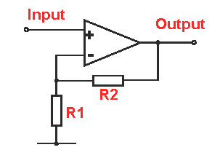

Figure 1.1 A basic Non-inverting Op-amp [38].

In figure 1.1, a basic non-inverting op-amp was shown. The gain of this non-inverting op-amp is [38]

* + - 1. Right-Leg Driven Circuit

Right-Leg Driven Circuits are used with biopotential differential amplifiers to reduce common mode voltage [41].

* + - 1. Filter

An electrical filter is a circuit that can be designed to modify, reshape or reject all unwanted frequencies of an electrical signal and accept or pass only those signals wanted by the circuit designer [40].

* + - 1. Notch Filter

A Notch filter is a type of bandstop filter that reduces a narrow range of frequencies. For example a notch filter in a musical instrument amplifier may r educe frequencies in the range 49 to 51 Hz, which is sufficient to eliminate any hum coming from the 50 Hz power line [39].

* + - 1. Low pass filter

A low pass filter is a filter which passes low-frequency signals and blocks or impedes, high frequency signals [41].

* + - 1. High pass filter

A high pass filter is a filter which passes high frequency signals and blocks or impedes, low frequency signals [42].

* + - 1. Data Acquisition

Data acquisition is the process of measuring an electrical or physical phenomenon such as voltage, current, temperature, pressure, or sound with a computer [3].

* + - 1. Arduino

Arduino is an Open-source platform used for building electronics projects. Arduino consists of both the physical programmable circuit board and a piece of software or IDE (Integrated Development Environment) that runs on your computer, used to write and upload code to the physical board [4].

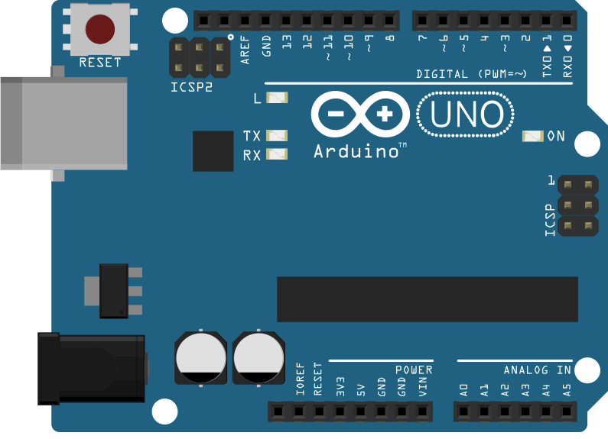

Figure 1.2 Image of Arduino Uno [5].

* + - 1. MATLAB

MATLAB is a high-performance language for technical computing. It integrates computation, visualization, and programming in an easy-to-use environment where problems and solutions are expressed in familiar mathematical notation.



Figure 1.3 MATLAB 2015a logo [6].

* 1. Block Diagram of the Project

This block diagram describes the overview of our project. Firstly we will put the bio-signal from the human being through electrodes to the bio-amplifier trainer, then from the trainer through the data acquisition system we will see the real-time output on MATLAB.

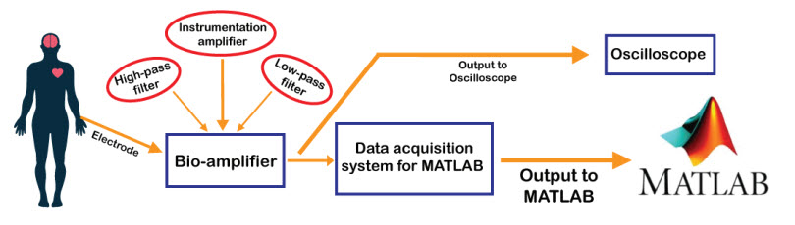

Figure 1.4 Block diagram of this project.

* 1. Future Scope of this Project

The work presented in this project can be extended in several directions. The project can be extended to:

* To design better ECG, EEG and EMG signal circuit.
* To design more accuracy in ECG, EEG and EMG signal receiving.
* To design the modular for commercial purpose.
* To design the circuit for ECG, EEG and EMG data recording in memory.
* Number of leads for ECG, EEG and EMG measuring can be improved.

Chapter 2

Bioamplifier

* 1. Introduction

Acquiring different bio-potentials needs different techniques for measurements and amplifications. Bio amplifiers are also different in nature depending on the use and requirements. Measuring the ECG, EEG and EMG has different methods although the techniques are moreover same.

* 1. Biopotential

Bio-potential is an electric potential that is measured between points in living cells, tissues, and organisms, and which accompanies all biochemical process [1].Three Bio-potentials mostly used in various researches are Electrocardiogram(ECG), Electroencephalogram(EEG) and Electromyogram(EMG). Electrocardiography depends on the measurement of changing potentials in contracting heart muscle. Electromyography and Electroencephalography function similarly in the diagnosis of neuromuscular and brain disorder respectively.

* + 1. Electrocardiogram (ECG)

Electrocardiogram (ECG) is the electrical activity of the heart. ECG depends on the measurement of potentials changing in contracting heart muscles.

* + - 1. Heart Conduction System

The heart is made of involuntary muscles. Heart contains four chambers through which blood is circulated throughout our body. So it is very important to understand its functions, structure theory related to this. We have three pacemaker cell present in our heart [7]. The cardiac muscle cell and conducting fiber are responsible for heart conduction. Signals conduct from SA node to Purkinje fiber via AV node, Bundle branches.

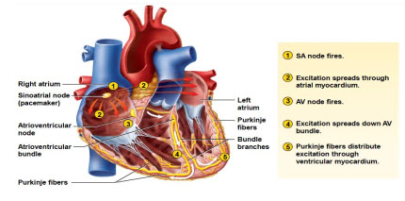

Figure 2.1 Heart cross section view with valves & parts [8].

It proves that heart automatically beat due to the presence of pacemaker cells. The SA node pumps for which excitation reaches the atria myocardium. Then AV node pumps. Then excitation comes to bundle branches. Then stimulation flow to the purkinje fibers across the heart. In this way, heart beat generate in the cardiac system. So we can interpret the signal as voltage response and classify them into different diseases. So it is very important for us to understand the mechanism inside the heart for ECG measurement. Blood is circulated in and out of the heart due to this topology. This pacemaker cell is continuous and blood enters into cells filling up the Arial chamber. Depolarization pumps blood to ventricles. After passing through the lungs for purification and circulates back to the heart for the next pumping cycle. In this way, heart supplies blood throughout the body [9].

* + - 1. About Electrocardiography (ECG)

Electrocardiography records the heart activity over a period of time using electrodes placed on human body. Electrodes detects small electrical changes on the skin that shown from the heart muscle depolarizing during each heartbeat. In 12 lead ECG, ten electrodes are placed on the patient’s limbs and on the surface of the chest. The value of the heart’s electrical activity is then measured from 12 different angles and is recorded for some period of time. In this way, magnitude and direction of the heart’s electrical depolarization is captured at each moment throughout the heart cycle [10]. The graph of voltage vs time produced by this non-invasive medical procedure is teemed as electrocardiogram. During each heartbeat, a healthy heart beat villa have a consequence of depolarization that starts with pacemaker cells into the SA node, moves out through the atrium, passes through the AV node down into the bundle of His and into the Purkinje fibers. Then it enters into left throughout the ventricles. This sequential pattern of depolarization gives output to the characteristic EOG signal. An Ego represents a huge amount of data about the structure of the about the structure of the heart and generation of the electrical conduction system. Like other things, an EOG can be used to measure the heart beat and oscillation of heartbeats, the size and location of the heart chambers, the presence of any injury to the heart’s muscle cells or conduction system.

* + - 1. Historical Background of ECG

Alexander Muirhead is regarded to have connected wires to a feverish patient’s wrist to get a record of the patient’s heart rate in 1872 at St Bartholomew’s Hospital. His electrocardiograph machine made of a Lippmann capillary electrometer fixed to a outputted. The presence of the heartbeat was caught onto a photographic plate that was fixed to a toy train itself. This permit a heartbeat to be counted in real time. When willem Einthoven used the string galvanometer he invented in 1901 that was an earlier achievement in the ECG field.

This device was strongly sensitive than both the capillary electrometer of Waller and the string galvanometer by the French engineer Clement Ader. Einthoven assigned the letter P, Q, R, S, and T to the different deflected waves, and described the ECG features as disorder cardiovascular activity. Though the basic idea of that time is still in use today, many advances electrocardiography have been made over last decade [11].

* + - 1. Action potential in Cell

Heartbeat is certain rhythm due to this pacemaker cell. Electrical conduction in the body and in bio-potential of ions are Na-, K+, CI-, Ca++ Voltage-gated ion channels potentials that propagate across the heart. This pacemaker cell has the property of automaticity [12]. This potential is in mV tinge. There are few ion that will pass into and out of the cell. If calcium is the only ion that is moving in & out of the cell then cell voltage would be 123mV.

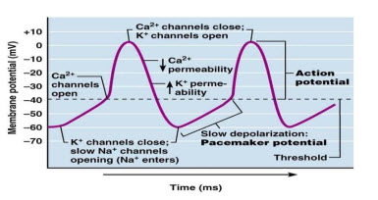

Figure 2.2 Action potential of pacemaker cell [13].

Is Na+ the only ion present in the cell then membrane potential will be 67 mV. So if K+ is the only ion then the potential would be only -92 mV. Then cell is permeable to only K- ions so k will go out. Then Na+ channels open and K- channel close. When the potential reached to – 40 mV then Ca- channel open. Ca- ions enter until the potential reached up to 10 mV. Then suddenly k- channel starts to leave the cell and the potential reached up to -60 mV where it starts. Just like Ca- channels stops, k- channels also stops suddenly. In this way how action potential in pacemaker cell happened. So pacemaker cell is continuously in motion [14].

* + - 1. Characteristics of ECG

An ECG measures changes in electrical voltage over time. The electrical voltage is caused by a group of pacemaker cells in the heart which control over the heart rate. These cells produce electrical conduction which conducts across the heart tends it to contract. The heart’s main pacemaker, the Senatorial node (SA node), start the heartbeat by supplying an electrical impulse which moves to the left and right atria, causing them to contract (atria depolarization) [25]. After the start of atria depolarization, the response quickly found at the Atrioventricular node (AV node) that is responsible for control of ventricle contraction. So the doctrinal signal then passes through the Bundle of His, breaks into the Right and Left Bundle branches, and passes through the Purkinje fiber to the muscles of the left and right ventricle, causing both to contract (ventricular depolarization). The time required for the signal to travel from the AV node to the Purkinje Fibers provides a natural delay required for the atria to fill up the ventricles with blood. During the previous depolarization wave. The contraction is followed by recovery (ventricular repolarization) of the cells which were excited.

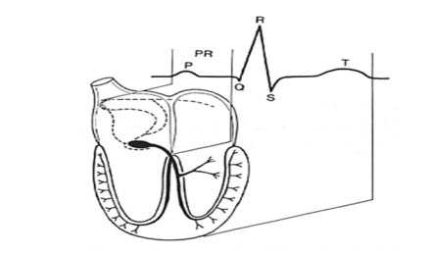

Figure 2.3 Heart conduction system by pacemaker cell [9].

P wave –Atrial depolarization

QRS wave- Ventricular depolarization

T wave- Ventricular repolarize

There is three pacemaker cell in our heart:

* Sino-Atrial node(SA node) (60-100beat rate)
* Atrial –ventricular node(AV node) (40-60 beat rate)
* Ventricular cells(20-40 beat rate)

The SA node create the electrical signal which causes the heart to beat, but the autonomic nervous system (ANS) controls the heart beat along with the strength of heart contractions. THE ANS consists of two parts, one sympathetic Nervous system and another is parasympathetic nerves system. The sympathetic nerves increase the heart rate and the contraction force, Whereas the parasympathetic nerves act in the opposite manner.to be useful as a biometric the start and end of the P and T waves are also recorded. The nine distinguishing features (L’, P, P’, Q, R, S, S’, T, and T’) of a heart beat are identified in the idealized ECG signal [9].

* + - 1. Lead System of ECG

The lead system of ECG is a very important step in interpreting them. The heart is a 3-D organ, so electrical activity must depends in 3-D as well. So the lead system is very important to understand in ECG part. Our lead system is **3 leads**. Each lead views the heart at a unique angle, enhancing its sensitivity to a particular region of the heart. Electrodes are attached to the right and left arm. Right leg electrode functions as an electrical ground only. It prevents alternating currents interference and can be ignored. Electrically activity is only conducted through the torso to the extremities.

* **Bipolar Leads (Leads I, II, III)**

Named because they record the difference in voltage between 2 extremities. Lead I-difference in voltage between the left arm and right arm. Lead II-the difference in voltage between the left leg and right arm. Lead III difference in voltages between the left leg and left arm.

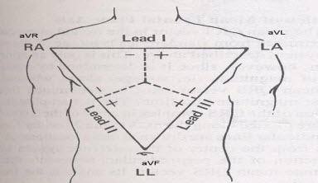

Figure 2.4 Bipolar leads of ECG interpretation [19].

Einthoven’s triangle: Einthoven triangle is the representation of bipolar leads on the side of the triangle. It demonstrates the angle of orientation of the three bipolar leads (I, II, III).Each lead has a positive and negative pole which the machine automatically designates.

Lead I-points horizontally. Its left pole is positive therefore=LA.RA. Lead II –points diagonally downwards. Its lower pole is positive and upper negative therefore=LL.RA. Here Lead I+ Lead III=Lead II

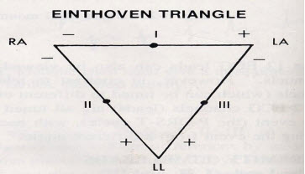

Figure 2.5 Einthoven triangle representation [20].

There is also unipolar leads and 12 leads available. Dr. Frank Wilson invented the unipolar chest leads. Leads are V1 to V6. Leads are placed in horizontally plane. They record Voltages moving anteriorly and posteriorly [16].

12 leads system have 8 independent leads and 4 reduced leads [16].

* + 1. Electroencephalogram (EEG)

An Electroencephalogram (EEG) is a test used to evaluate the electrical activity in the brain. Brain cells communication with each other through impulses. An EEG can be used to help detect potential problem associated with this activity [15]. The amplitude of the EEG id about 1-2 mV when measured on the surface of the brain. The bandwidth of the signal is under 1 Hz to about 50 Hz as demonstrated in figure 2.6.As the phrase “spontaneous activity” implies, this activity goes on continuously in the living individual [16].

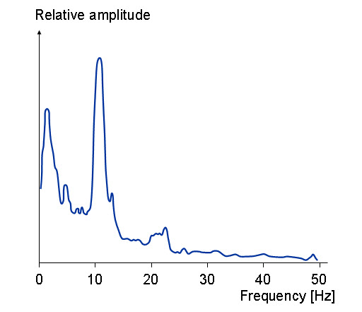

Figure 2.6 Frequency spectrum of normal EEG [16].

* + - 1. Historical Background of EEG

The first recording of the human brain was made by the German psychiatrist Hans Berger in 1924 in Jena. He gave this recording the name electroencephalogram (EEG). From 1929 to 1938 he published 20 scientific papers on EEG under the same title “Uber das Elecktroenkephalogram das Menchen” [16].

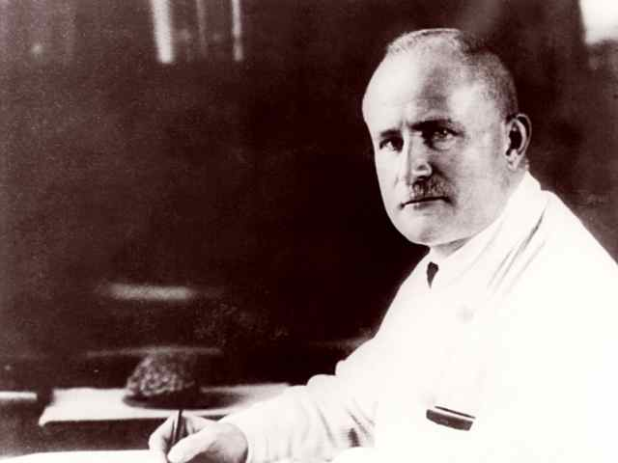

Figure 2.7 Hans Berger at the University of Jena [17].

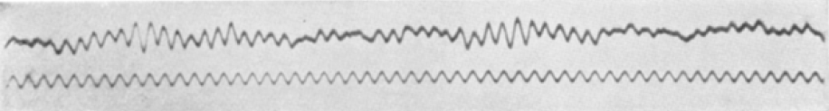

Figure 2.8 One of the first Published EEGs of a human [18].

In Figure 2.7, shown the Hans Berger at the University of Jena. In figure 2.8, shown one of the first published EEGs of a human. This image is one of the first EEGs, Appearing in Berger’s first report. The top trace is the EEG recorded from a young boy, the bottom trace is a 10 Hz frequency reference [18].

* + - 1. The Behavior of the EEG signal

From the EEG signal it is possible to differentiate alpha (α), beta (β), delta (δ), and theta (ϴ) waves as well as spikes associated with epilepsy. An example of each waveform is given figure 2.9

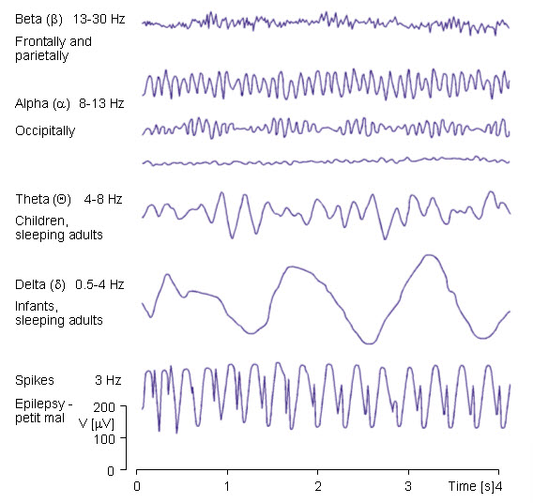

Figure 2.9 Some example of EEG waves [16].

The alpha waves have the frequency spectrum of 8-13 Hz and can be measured from the occipital region in an awake person when the eyes are closed. The frequency band of the beta waves in 13-30 Hz, these are detectable over the parietal and frontal lobes. The delta waves have the frequency range of 05-4 Hz and are detectable in infants and sleeping adults. The theta waves have frequency range of 4-8 Hz and are obtained from children and sleeping adults.

* + - 1. The Basic Principle of EEG diagnosis

The EEG signal is closely related to the level of consciousness of the person. As the activity increases, the EEG shifts to higher dominating frequency and lower amplitude. When the eyes are closed, the alpha waves being to dominate the EEG. When the person falls Asleep, the dominate EEG frequency decrease. In a certain phase of a sleep, rapid eye movement called (REM) sleep, the person dreams and has active movements of eyes, which can be seen as a characteristic EEG signal. In deep sleep, the EEG has large and slow deflections called delta waves. No cerebral activity can be detected from a patient with complete cerebral death. Examples of the above –mentioned waveforms are given in Figure 13.6

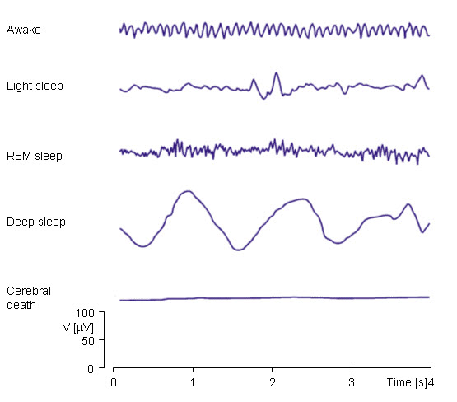

Figure 2.10 ECG activity depends on the level of consciousness [16].

* + - 1. EEG Measuring Method

For acquiring the EEG signal we had used the 3 lead method in out Universal Trainer module and we had targeted to measure the Alpha range of the ECG signal.

* **Alpha**

Alpha has a frequency between 7 and 13 Hz. IS usually best seen in the poster regions of the head on each side, being higher in amplitude on the dominant side. It appears when closing the eyes and relaxing, and disappears when opening the eyes or alerting by any mechanism (thinking, calculation). It is the major rhythm seen in normal relaxed adults. It is present during most of life especially after the thirteen years [21].

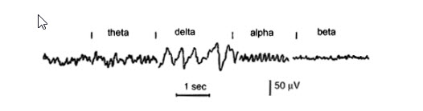

Figure 2.11 Main frequencies of human EEG wave [21].

In our EEG Measurement we had placed one electrode each in the poster region of the head on each side and put third electrode on the ear which act as ground.

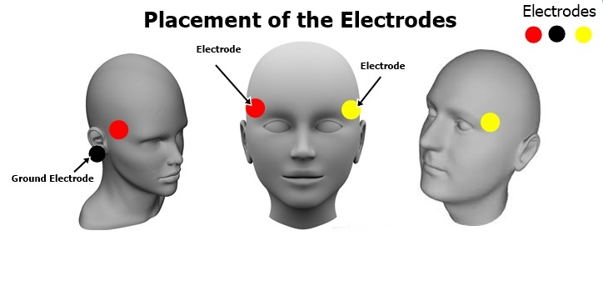

Figure 2.11 Placements of the 3 Electrodes [22].

* + 1. Electromyography (EMG)

Electromyography (EMG) is an experimental techniques concerned with the development, recording and analysis of myoelectric signal. Myoelectric signals are formed by physiological variation in the state of muscles fiber membranes [1].

Besides basic physiological and biomedical studies, EMG established as an evaluation toll for applied research, physiotherapy/rehabilitation, sports training and interactions of the human body to industrial products and work conditions.

* + - 1. Historical Background of EMG

Scientists in the 17th and 18th centuries such as Jan Swammerdam, Francesco Redi, Luigi Galvani, and Alessandro Volta conducted experiments to confirm that electrical stimulation led to muscle contraction. Carlo Matteucci was the first to develop a primitive instrument related to modern EMG to measure electrical potential in muscles. His galvanometer detected and determined the direction of small electrical currents produced by mechanical means, and then applied this to muscles contraction through studies done on frogs. Emil Du Bois –Raymond was the first to apply this to voluntary contraction of human muscle, and his work was followed by further experimentation by Guillaume Duchene on facial muscles. Since then, EMG machines were refined and knowledge of EMG furthered at unbelievable speeds [26].

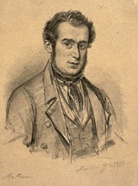

Figure 2.12 Picture of Carlo Matteucci [24].

* + - 1. Present and Future Use of EMG

EMG is currently used in the diagnosis of several of neuromuscular diseases. It has also been used to help study Kinesiology as well as help map the brain for deeper understanding of Alzheimer’s .A current use that has a prevalent future is utilizing EMG for prosthetics movement. This has been widely used in prosthetics for limbs such as arms, hands and legs.

In addition to medical uses, use of EMG in the gaming industry is a future source for expansion [26].

* + - 1. Generation Of EMG Signal

The EMG is generated when a motor neuron action potential from the spinal cord arrives at a motor and plate.

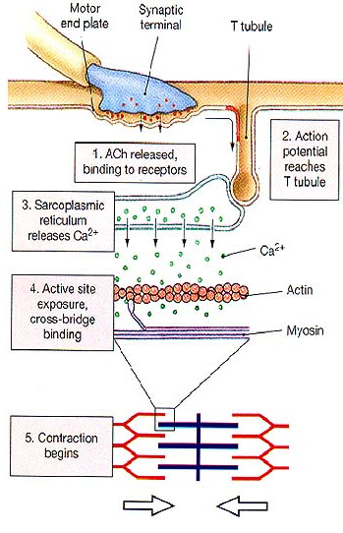

Figure 2.13 Generation of EMG signal [25].

Its arrival causes a release of Ach (Acetylcholine) at the synaptic cleft (1) which causes a depolarization (Action Potential). This action potential electrically travels downward from the surface in a transverse tubule (2). This in turn causes a release of CA++( 3),causing cross-bridge binding (4) and he sarcomere of the muscle to contract(5).

An electromyography (EMG) is a measurement of the electrical activity in muscles as a byproduct of contraction. An EMG is the summation of action potentials from the muscle fibers under the electrodes placed on the skin. The more muscles that fire, the greater the amount of action potentials recorded and the greater the EMG reading [25].

* + - 1. EMG recording

The EMG is recorded by using an electrode placed on the muscle. The electrical activity measured by each muscle electrode and the ground electrode are sent to an amplifier.

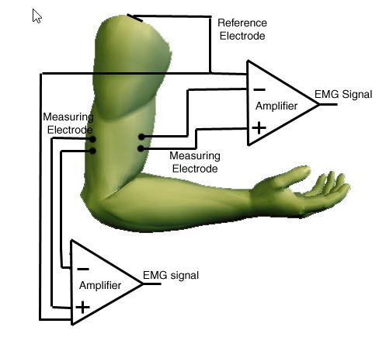

Figure 2.14 A general block diagram of EMG signal recording [25].

The amplifier elements random voltages caused by electrical noise by subtracting the signal from the found electrode from muscles electrode, producing the raw EMG.

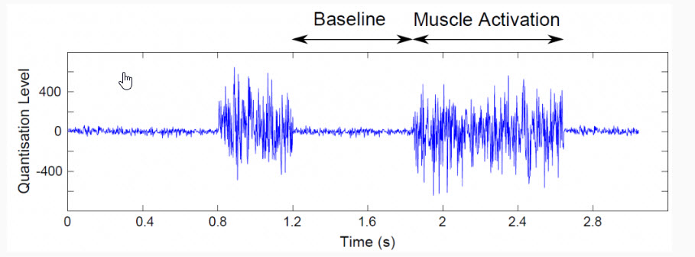

Figure 2.15 A normal EMG signal with muscle activity [27].

In figure 2.15, shown normal EMG signal with the baseline and muscle activation. Here we can see how the EMG signal changes due to muscle activities.

* 1. Bio-Amplifier

A bio-amplifier is a device used to gather and increase the signal integrity of human neurophysiology electrical activity for output to various sources.

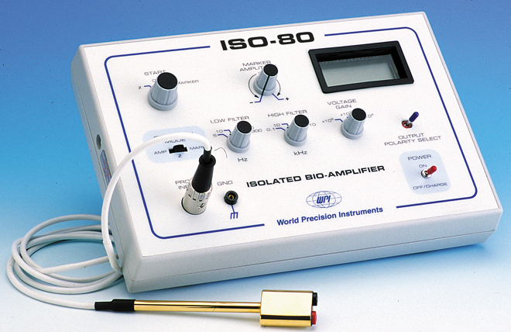

Figure 2.16 A picture of isolated bio-amplifier [29].

* + 1. History of Bio-Amplifier

The attempts to amplify biosignal started with the development of electrocardiography. In 1887 Augustus Waller, a British physiologist , successfully measured the electrocardiography of his dog using two buckets of saline, in which each of the front paws and hind paws was submerged. After a few months, Waller successfully recorded the first human electrocardiography using the capillary electrometer. Although, Waller did not envision that electrocardiography would be used in healthcare extensible, at the time of his invention. The electrocardiography did not have a practical usability until Willem Einthoven, a Dutch physiologist, coined the way to use the string galvanometer in cardiac signal amplification. Significant improvements in amplifier led to the usage of smaller electrodes that would be more easily attached to body parts. In the 1920s, the way to electrically amplify the cardiac signals was introduced, using vacuum tubes, which quickly replaced the string galvanometer that amplified the signal mechanically. The vacuum tubes had larger impendence, so the amplification was more robust. Also, its relatively small size compared to the string galvanometer also contributed the widespread of the vacuum tube. Also the large metal buckets were no longer needed, as much smaller metal –plate electrodes were introduced. By the 1930s the electrocardiogram devices could be carried to the patient’s home for the purpose of besides monitoring with the emergence of electronic amplification, it was quickly discovered that many features of the electrocardiography were revealed with various electrode placement [28].

* + 1. Bio-amplifier for ECG

Electrocardiography records the electrical activity of the heart, across the surface of the thorax skin. The signals are detected by electrodes attached to the surface of skin and recorded by a device external to the body.

The amplitude of ECG ranges from 0.3 to 2 mV for the QRS complex, which is used to determine the interbeat interval from which the frequency is derived [28]. The typical requirements for the amplifiers to be used in ECG include:

* Low internal noise
* High input impendence
* Bandwidth ranging from 0.16-250 Hz
* Bandwidth cutoffs.
* Notch filter
* Common mode rejection ratio
* Common mode input range
* Static electricity shock protection.
  + 1. Bio-amplifier for EEG

Electromyography records the electrical activity produced by skeletal muscels.it records various type of muscle signals from simple relaxation by using placing electrodes on the subject’s forehead, to complex neuromuscular feedback during stroke rehabilitation. The EMG signals are acquired from the electrodes applied over or nearby muscles to be monitored. The electrodes delegates signals to the amplifier unit, usually consisting of high performance differential amplifiers. The usual types of the signal of the interest are in the range of 0.1-200 mV amplitude, over a bandwidth of about 25-500 Hz [28].

Although many electrodes still connect to an amplifier using wires, some amplifiers are small enough to mount directly on the electrodes. Some minimal specifications for a modern EMG amplifier includes:

* Low internal noise
* High input impendence
* Flat bandwidth and sharp high and low frequency cutoffs
* High common mode rejection ratio
* Common mode input range
* Static electricity shock protection
* Gain stability >±1%
  + 1. Bio-amplifier for EMG

Electroencephalography instrumentation is similar to EMG instrumentation in terms of involving the placement of many surface electrodes on the patient’s skin, specifically, on scalp. While EMG acquires the signals from muscles below the skin, EEG attempts to acquire signals on the patient’s scalp, generated by brain cells. Simultaneously, EEG records the summed activity of tens of thousands to millions neurons. As the amplifiers became small enough to integrate with electrodes, EEG has become to have the potential for long term use as a brain-computer interface, because the electrodes can be kept on the scalp indefinitely. The temporal and spatial resolutions and signal to nosed ratios of EEG have always lagged behind those of comparable intracortical devices, but it has the advantages of not requiring surgery [28].

High performance differential amplifiers are used for amplification. Signals of interest are in the range of 0.5-100v, over the frequency range of 1-50Hz.similar to EMG amplifiers, EED benefits from the usage of Integrated circuit. The chances of EEG is also mainly from the asymmetrical placement of electrodes, which leads to increased noise or offset [28]. Some minimal specifications for a modern EEG amplifier includes:

* Low interval voltage and current noise
* High input impedance
* Bandwidth
* Frequency cutoffs
* High common mode rejection ratio
* Common mode input range
* Static electricity shock protection
* Gain stability > ±1%
  1. Background Studies

Biomedical engineering is one of the core sectors of engineering from the beginning of the realization of various bio-potential activities in living beings. For practical physiological understanding, realization and measuring of those bio-potential activities in education and research purposes various international and multinational tech companies introduced many bio-amplifier modules. Some international tech companies are BIOPAC, OpenBCI, Mega Electronics Ltd, NI Instrument, Texas instruments, Bi-beat, AD INSTRUMENTS etc.

* + 1. Tech Companies Modules
       1. BIOPAC

One of the leading educational bio-amplifier module manufacturers is BIOPAC. BIOPAC was founded in 1985 and, with over 30 years of success, is recognized around the world as a premier choice for life science hardware and software.



Figure 2.17 Logo of BIOPACK [30].

BIOPAC has a module called ``MP Acquisition Unit’’.

MP36/35 Four Channel Data Acquisition System

MP45 Two Channel Data Acquisition System

The MP Unit has an internal microprocessor to control data acquisition and communication with the computer. The MP Unit takes incoming signals and converts into digital signals that can be processed with the computer. There are analog input channels (four onMP36/35 units, two on MP45), one of which can be used as a trigger input, The MP Unit must be connected to the Computer and electrodes, transducers, and/or I/O devices must be connected to the MP Unit.

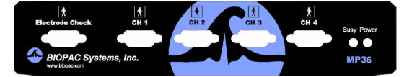

Figure 2.18 Front penal MP 36/36 [30].

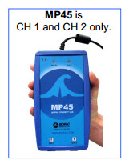

Figure 2.19 BIOPAC’s MP44 [30].

* + - 1. BiBeat

In Our country we also have a tech company called `` BiBEAT’’ that manufacture bio-medical educational equipment. BiBEAT is a non-shareholding company with the aim of developing and delivering low cost medical equipment.

Along with the other equipment BiBeat has 2 bio-amplifier modules given below,

* 12 Lead ECG
* NCV-EMG

**12 lead ECG**

BiBEAT 12 lead ECG is a compact 7 inch unit with software. Just connect the unit to a desktop or laptop computer through the USB port, run the given software and you will get a full ECG machine. The user friendly graphical useriterface (GUI) will guide you through every step and you can choose each of the 12 leads by simple mouse clicks. You’ll see all the ECG traces on the screen which you can then save together with necessary patient information for future use. You can get the traces permanently printed on ordinary paper using any computer printer (color printer preferred). These will not fade out with time as happens with thermal prints used in most common ECG machine. Using the same software you can send the ECG data to any specialist cardiologist, anywhere in the world through internet, in real time. Thus you can use this equipment for stane-aloneuse, or for Telemedicine. Based on our previous experience, we feel fairly confident that you can use this equipment for decades with satisfaction.

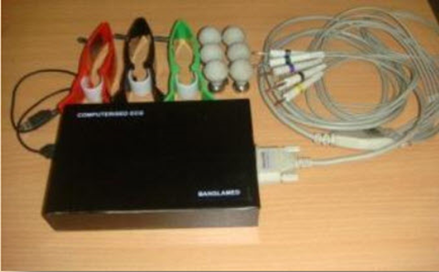

Figure 2.20 BiBEAT’s 12 Lead ECG module [31].

**NCV-EMG**

It is a PC based duel option system that gives nerve conductivity measurement device with simulator. It has a USB interface for PC Connectivity. Power obtained from USB port, no external power necessary.

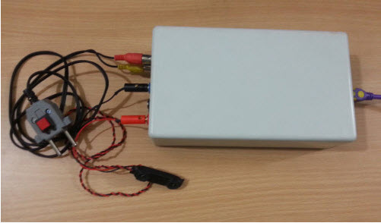

Figure 2.21 NCV-EMG [32].

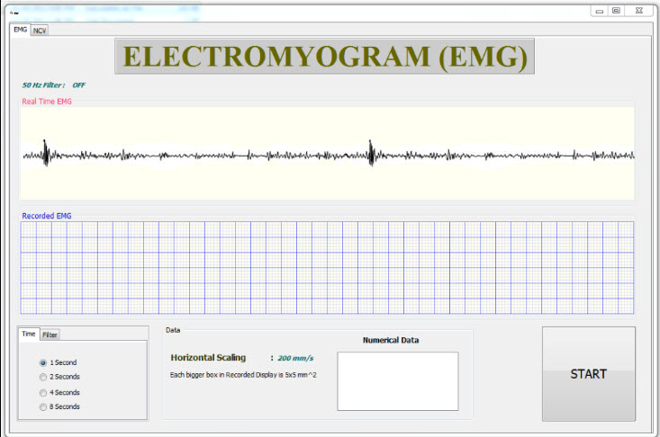

Figure 2.22 Output of NCV-EMG [32].

* + - 1. OpenBCI

OpenBCI stands for open-source brain-computer interface (BCI). This is a community of researchers, engineers, artists, scientists, designers, makers, and more. OpenBCI has many devices for the educational and research purposes. Among those DEVICES R&D Kit (16-channel) – 32bit, Daisy, & Accessories is the all in one module.

R&D Kit (16-channel) – 32bit, Daisy. & Accessories The OpenBCI 32bit board and OpenBCI Daisy Module (which plugs into the OpenBCI 32bit Board) can be used to sample brain activity (EEG), muscle activity (EMG), and heart activity (EKG). The system communicates wirelessly to a computer via the OpenBCI Programmable USB dongle, which is based on the RFDuino radio modeled. It can also communicate wirelessly to any mobile device or tablet compatible with Bluetooth Low Energy (BLE).

|  |  |
| --- | --- |
| Figure 2.23 OpenBCI R&D Kit [33]. | Figure 2.24 Visualizer of OpenBCI [33]. |

* + - 1. Mega Electronics Ltd

Mega Electronics Ltd is a Finnish medical technology company specialized in biosignal monitoring for cardiology, neurology, rehabilitation, occupational health and sports medicine since 1983. Company has developed cutting-edge technology for cardiac applications such as holstering, cardiac telemetry and cardiac rehabilitation, as well a high-end EEG solution for TMS-EEG and fMRI-EEG applications [34].



Figure 2.25 Logo of Mega Electronics Ltd [34].

* NeurOne Tesla

NeurOne Tesla is innovative research system developed by Mega Electronics. This neuroscience measurement system offers more accuracy, cleaner signal, faster sampling, modular solution and more flexibility and expandability by utilizing the latest advances in digital signal processing. NeurOne is a versatile system and it can be used widely in different neuroscience and psychological applications. NeurOne Tesla is especially designed for use together with trans cranial magnetic stimulators having extremely large dynamic range and special reduction technology to remove magnetic artifacts in short latencies. Advances amplifier design enables using both AC and DC recording modes the way you want. Innovative Tesla MRI amplifier brings MRI compatibility to NeurOne [35].

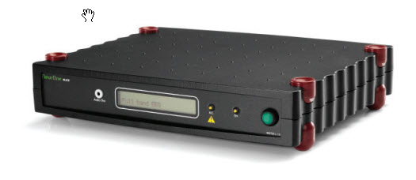

Figure 2.26 NeurOne Tesla [35].

* 1. Summary

In this chapter, we mainly discussed the key features of ECG, EEG and EMG signal with their required information & also discussed the modular are available in the market. Fist we discussed the three lead system of ECG, then we discussed the lead system of EEG after we discussed EMG lead system. At last, we discussed different kinds of modular which are separate modular boxes for ECG or EEG or EMG.

Chapter 3

Instrumentation

* 1. Introduction

To accomplish the main goal of this project, a modular trainer board is designed with 3 different type of bio signal receiver with data acquisition system. This trainer will be capable of selective recording of Electrocardiogram (ECG), Electroencephalogram (EEG) and Electromyogram (EMG) with multiple options of filtering. A data acquisition system will also be facilitated for the recording and amplifier interfacing with MATLAB with further processing, analysis, and extraction.

* 1. Electrocardiogram (ECG) Module

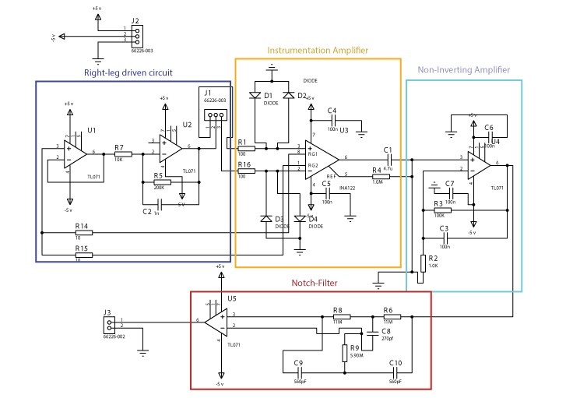

Figure 3.1 ECG Full Circuit Diagram.

* + 1. Equipmemts
* ECG Electrode.
* INA122 Instrumentation amplifier.
* TL071 Op-amp.
* Resistors: 10Ω, 100Ω, 1KΩ, 10kΩ, 100kΩ, 200kΩ, 1MΩ, 5.9M, 11MΩ.
* Capacitor: 1nF, 100nF, 4.7µF, 270pF, 560pF.
* Diode.
  + 1. Designing the Circuit

To make the design process easier the filter circuit was divided into 4 different steps. These steps are:

* A Right-leg driven circuit.
* An Instrumentation amplifier.
* A Non-inverting amplifier.
* A Notch filter.
  + 1. Right-Leg Driven Circuit

Common-mode rejection, or CMR, is one of the most important parameters for ECG system applications. In an ECG system, a large amount of electromagnetic interference (EMI) is coupled to the patient’s body through the skin. To reduce the CMR interference right-leg driven circuit was made up. Here is the circuitry of right-leg driven circuit given below.

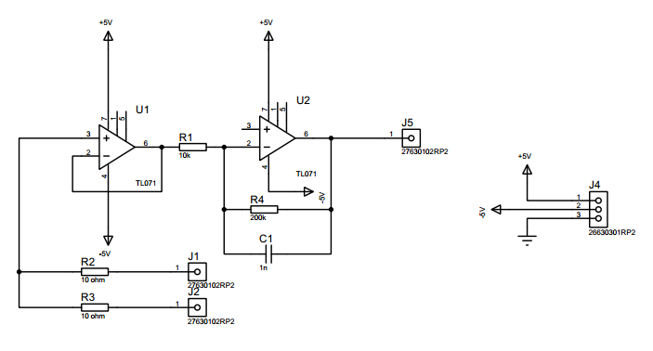

Figure 3.2 Right-Leg Driven Circuit.

* + 1. Instrumentation Amplifier

The voltage level of ECG signal is 1mV to 0.5mV. To make this signal usable for other filter circuits a great deal of amplification is required. That is the reason behind the application of the circuit. The INA122 operational amplifier was used to this specific range of the signal. Figure 3.1, shows the circuit diagram of the instrumentation amplifier. Instrumentation amplifier has a high gain. The amount of this operational amplifier is determined by gain resistor and the formula of the gain is,

$G=(1+\frac{49400}{R})$; Where R is gain resistor………………………. 3.1

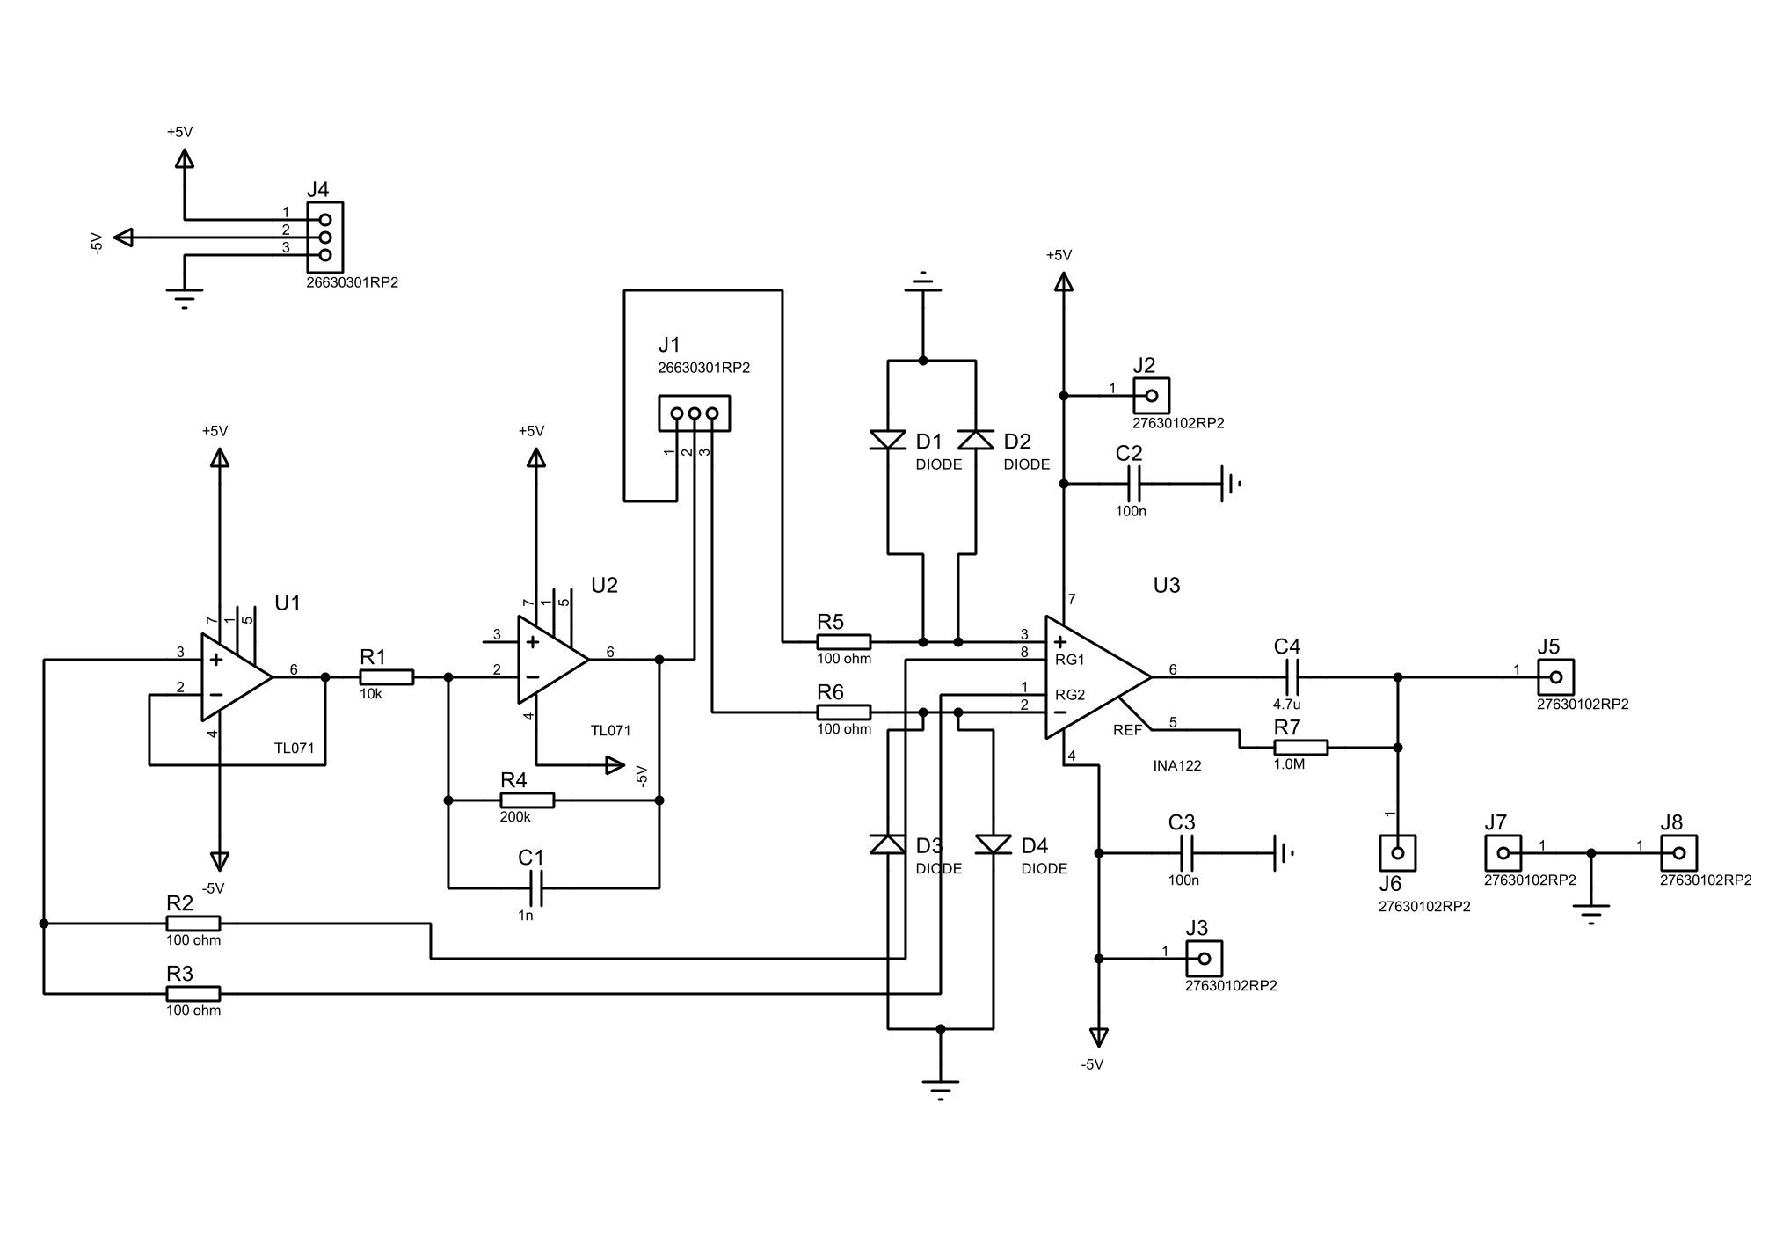

Figure 3.3 Instrumentation Amplifier.

If $R=50Ω$, using equation 3.1,

$$G=(1+\frac{49400}{50}) \\ =989$$

Circuit gain is 989, which is almost close to ideal gain.

* + 1. Non-Inverting Amplifier

The amplitude of the ECG signal decreases because of the active filter. So the ECG signal has to be amplified so that it can be transferred to the next stage. The main goal of designing a Non-inverting amplifier is to saturate all the ECG signals and convert them into an amplified waveform.

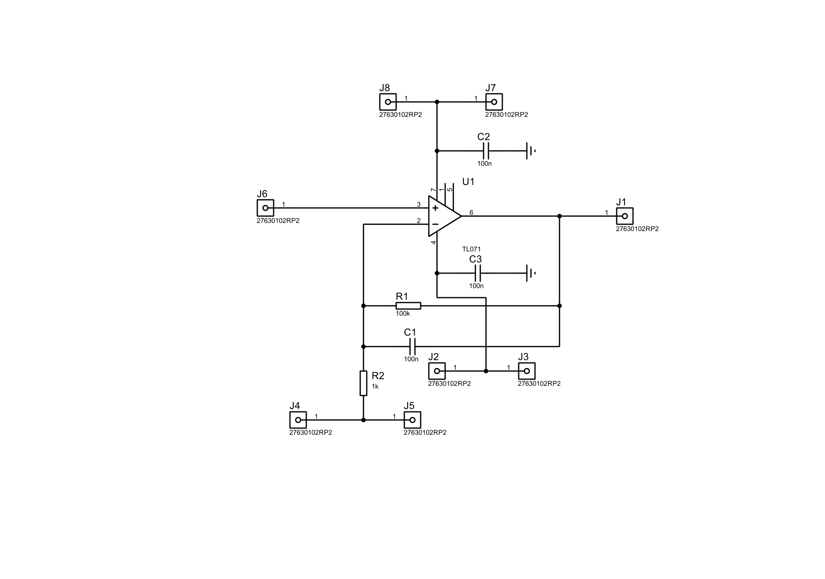

Figure 3.4 Non-Inverting Amplifier.

* + 1. Notch Filter

In every IC, there is a noise from a power source which is generated from the power line. This noise has the same frequency as the supply line. This noise can interfere with the desired signal. As the frequency of power supply in Bangladesh 50 Hz, a 50Hz notch filter was used.

The filter is actually known as twin T notch filter. The center rejection frequency of this circuit is determined by,

$f=\frac{1}{2π}\sqrt{\frac{1}{C2*C3*R3*(R1+R2)}}$……………………………...………3.2

Using the equation 3.2,

$$f=\frac{1}{2π}\sqrt{\frac{1}{\left(560*{10}^{-12}\right)*\left(560*{10}^{-12}\right)*\left(1*{10}^{6}\right)*\{\left(11*{10}^{6}\right)+\left(11*{10}^{6}\right)\}}}$$

$=49.49 Hz$

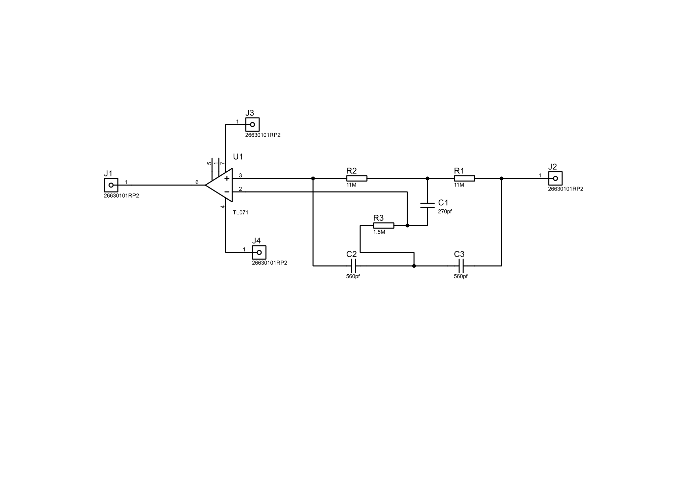

Figure 3.5 Notch Filter

* 1. Electroencephalogram (EEG) Module

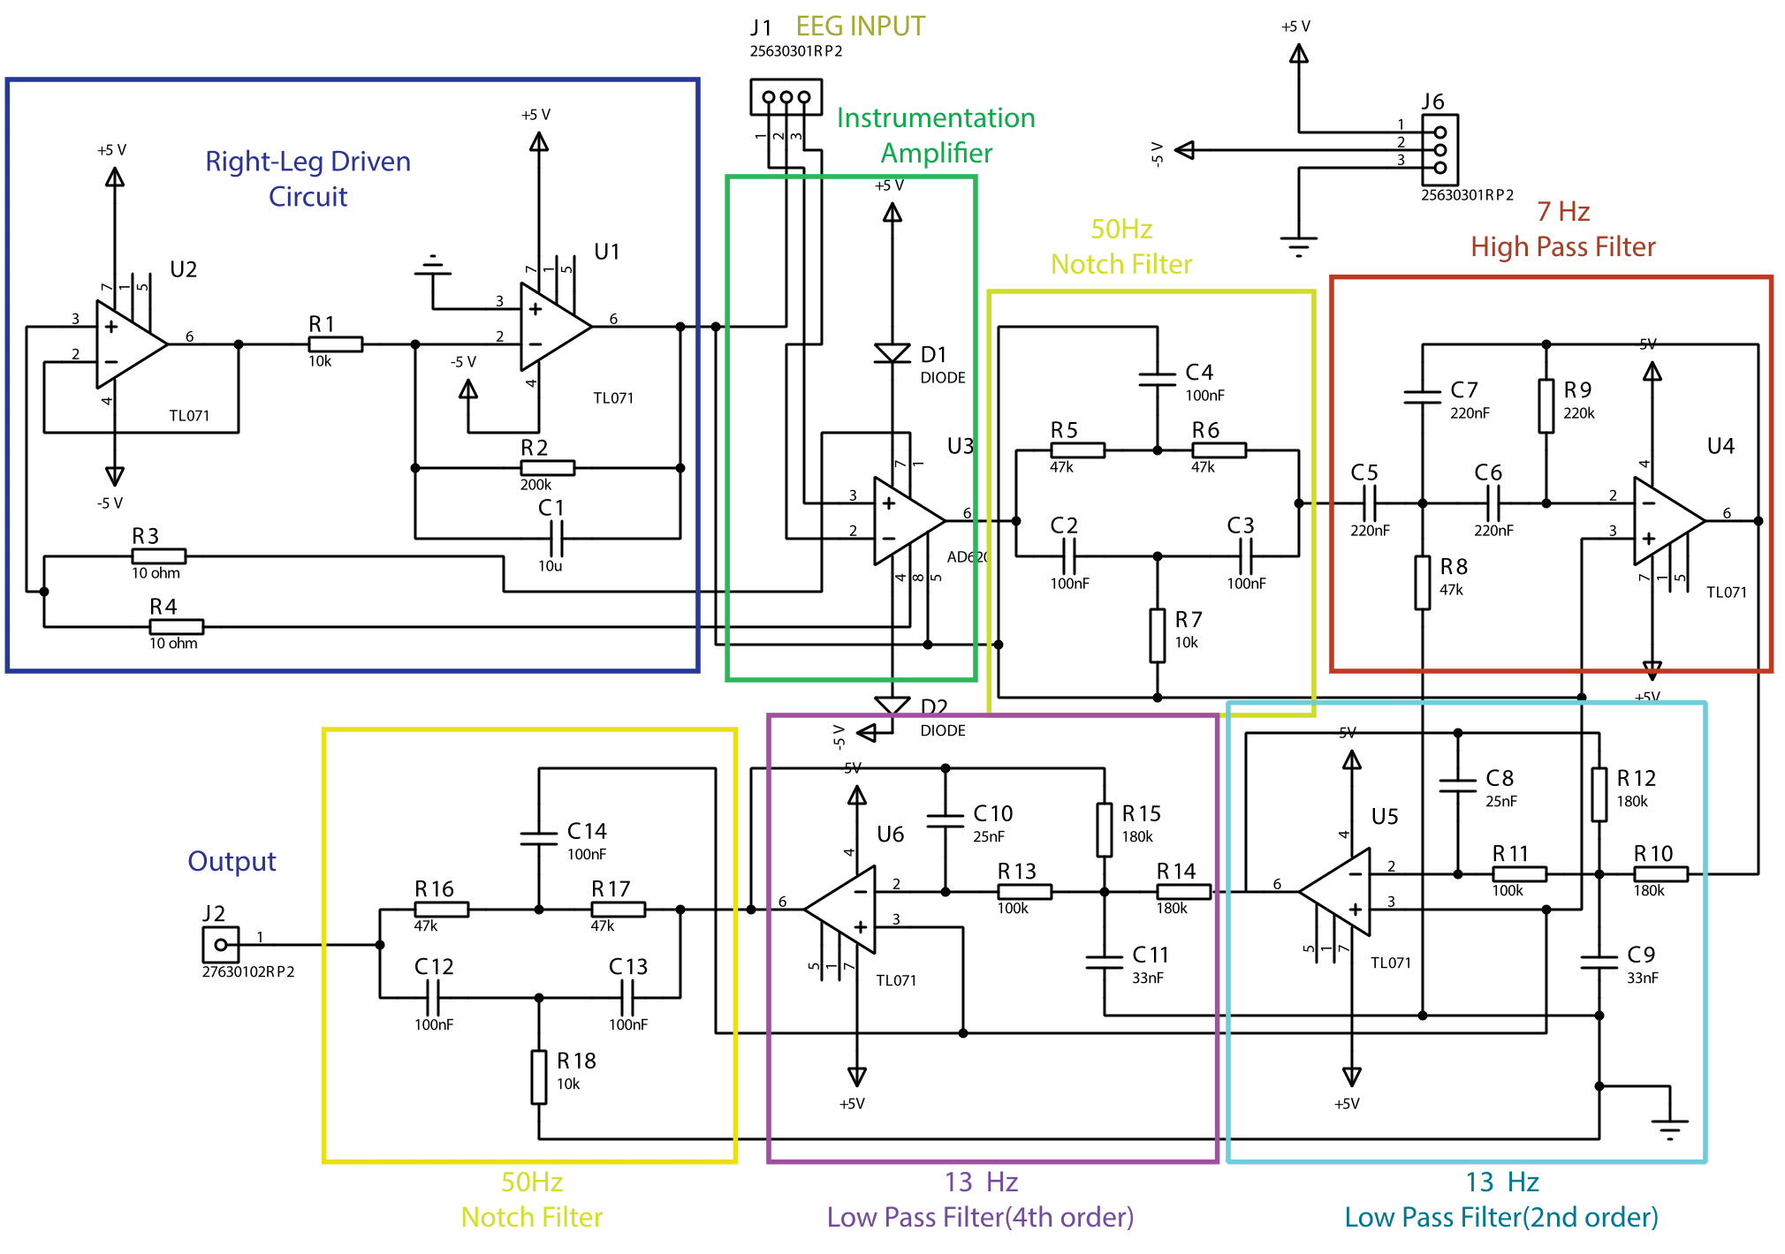

Figure 3.6 EEG full circuit diagram.

* + 1. Equipment
* EEG electrodes.
* AD620 instrumentation amplifier.
* TL071 Op-amp.
* Resistors: 10Ω, 10kΩ, 47kΩ, 100kΩ, 180kΩ, 200kΩ, 220kΩ.
* Capacitors: 1nF, 33nF, 100nF, 220nF.
* Diode
  + 1. Design the Circuit

To make the design process easier the filter circuit was divided into 4 different steps.

These steps are:

* A Right-leg driven circuit.
* An Instrumentation amplifier.
* Two 50Hz notch filter.
* A 7Hz High pass filter.
* A 13Hz Low pass filter (2nd order).
* A 13Hz Low pass filter (4th order).
  + 1. Right-Leg Driven Circuit

Right-Leg Driven Circuit was described in 3.2.3.

* + 1. Instrumentation Amplifier

The voltage level of ECG signal is 100 µV to 2mV. To make this signal usable for other filter circuits a great deal of amplification is required. That is the reason behind the application of the circuit. The AD620 operational amplifier was used to this specific range of the signal. Figure 3.7, shows the circuit diagram of the instrumentation amplifier. Instrumentation amplifier has a high gain. The amount of this operational amplifier is determined by a gain resistor. From the gain formula,

$G=(1+\frac{49400}{50})$ $$=989$$

Where, R is 50Ω.

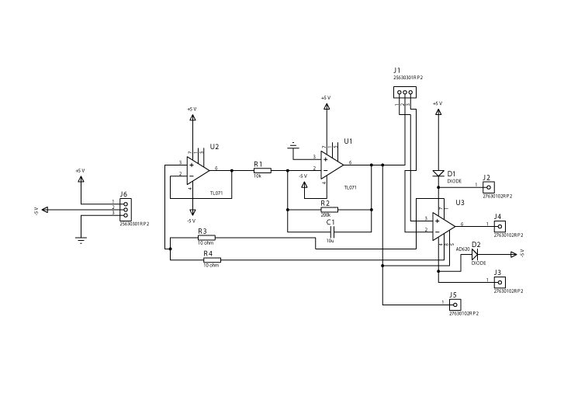

Figure 3.7 Instrumentation Amplifier.

* + 1. 50 Hz Notch-Filter

The filter was discussed before in 3.2.6.

The filter is actually known as twin T notch filter. The center rejection frequency of this circuit is determined by,

$f=\frac{1}{2π}\sqrt{\frac{1}{C2*C3*R3*(R1+R2)}}$……………………………...………3.2

Using the equation 3.2,

$$f=\frac{1}{2π}\sqrt{\frac{1}{\left(100*{10}^{-9}\right)*\left(100*{10}^{-9}\right)*\left(10*{10}^{3}\right)*\{\left(47*{10}^{3}\right)+\left(47*{10}^{3}\right)\}}}$$

$$=51.93 Hz$$

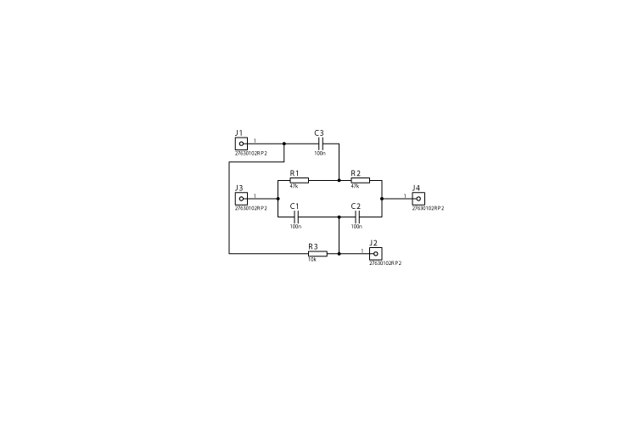

Figure 3.8 Notch Filter 50Hz.

* + 1. 7 Hz High Pass Filter

To cut off Delta and Theta waves, which have frequencies below 7Hz, a 7Hz high pass filter was needed. A 2nd order multiple-feedback high-pass filter was used to cut off those unwanted signals.

The equation of cut-off frequency is,

$f=\frac{1}{2π\sqrt{R1*R2*C2*C3}}$………………………………3.3

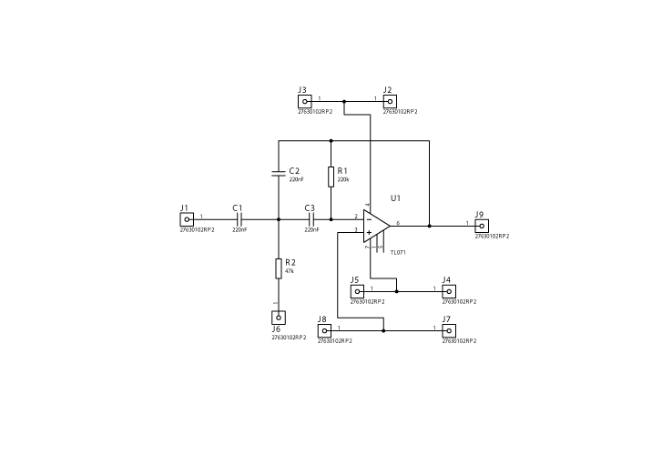

Figure 3.9 7Hz High Pass Filter.

For finding cut-off frequency equation 3.3 is used,

$$f=\frac{1}{2*3.1416\sqrt{\left(220*{10}^{3}\right)*\left(220*{10}^{-9}\right)*\left(220*{10}^{-9}\right)*\left(47*{10}^{3}\right)}}$$

$$=7.11 Hz$$

The equation of the gain is,

$G=\frac{c_{1}}{c_{2}}$………………………………………………………3.4

Using equation 3.4,

* + 1. 13 Hz Low Pass Filter

Since the frequency of the alpha wave is 8-12 Hz. A low pass filter circuit is needed that will cut off any frequency above 12 Hz. In the ideal case, the cut-off frequency of the low-pass filter would be 12 Hz. But in the practical scenario, the gain starts to drop quite before the cut-off frequency. In that case using a 12 Hz low pass filter would cause a data loss. That is why a 13 Hz low pass filter was chosen so that there is less attenuation in an alpha wave.

For finding cut-off frequency equation 3.3 is used,

$$f=\frac{1}{2*3.1416\sqrt{\left(220*{10}^{3}\right)*\left(100*{10}^{-9}\right)*\left(33*{10}^{-9}\right)*\left(180*{10}^{3}\right)}}$$

$=13.8 Hz$

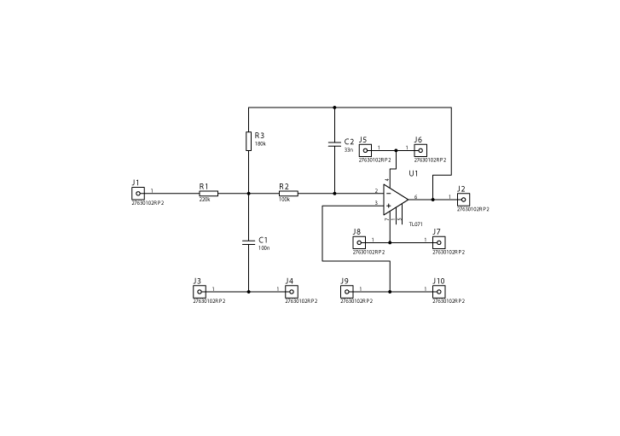

Figure 3.10 13Hz Low pass filter (2nd order)

13 Hz Low-pass filter (4th order):

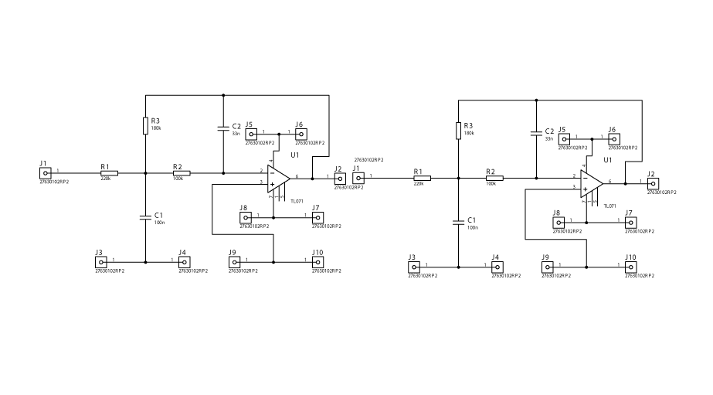

Figure 3.11 13Hz Low pass filter (4th order)

Fig 3.10 is the 13 Hz 4th order circuit diagram used for the reason to attenuate the signals above 12 Hz more so that the output at the end of the full circuit does not contain any signals above 12 Hz.

* 1. Electromyography (EMG) Module

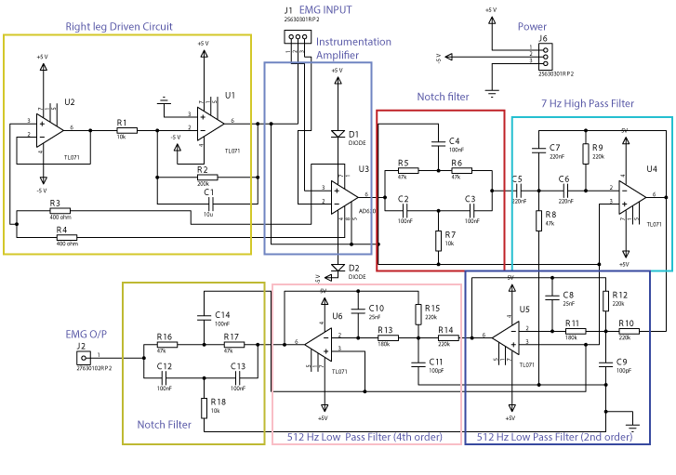

Figure 3.12 EMG full circuit diagram.

* + 1. Equipment
* EMG electrodes.
* AD620 instrumentation amplifier.
* TL071 Op-amp.
* Resistors: 10Ω, 10kΩ, 47kΩ, 100kΩ, 180kΩ, 200kΩ, 220kΩ.
* Capacitors: 1nF, 25nF, 100nF, 220nF, 100pF.
* Diode
  + 1. Design the Circuit

To make the design process easier the filter circuit was divided into 4 different steps. These steps are:

* A Right-leg driven circuit.
* An Instrumentation amplifier.
* Two 50Hz notch filter.
* A 7Hz High pass filter.
* A 512Hz Low pass filter (2nd order).
* A 512Hz Low pass filter (4th order).
  + 1. Right-Leg Driven Circuit

Right- Leg Driven Circuit was described before in 3.2.3.

* + 1. Instrumentation amplifier

Instrumentation amplifier was discussed before in 3.3.4

A little change has in gain in this amplifier from the EEG instrumentation amplifier.

From the gain formula,

$G=(1+\frac{49400}{200})$ $$=248$$

Where, R is 200Ω.

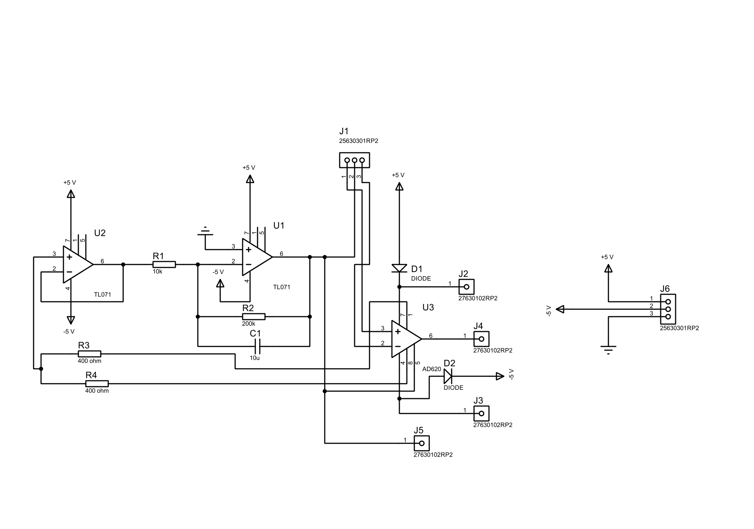

Figure 3.13 Instrumentation amplifier of EMG

* + 1. Notch Filter

Notch filter was described before in 3.3.5.

* + 1. 7 Hz high Pass Filter

7 Hz high Pass Filter was described before in 3.3.6

* + 1. 512 Hz Low Pass Filter

512 Hz low-pass filter was discussed before in 3.3.7

A little change has in cut-off frequency in this amplifier from the EEG low pass filter. For finding cut-off frequency equation 3.3 is used,

$$f=\frac{1}{2*3.1416\sqrt{\left(220*{10}^{3}\right)*\left(100*{10}^{-12}\right)*\left(25*{10}^{-9}\right)*\left(180*{10}^{3}\right)}}$$

$=506.1 Hz$

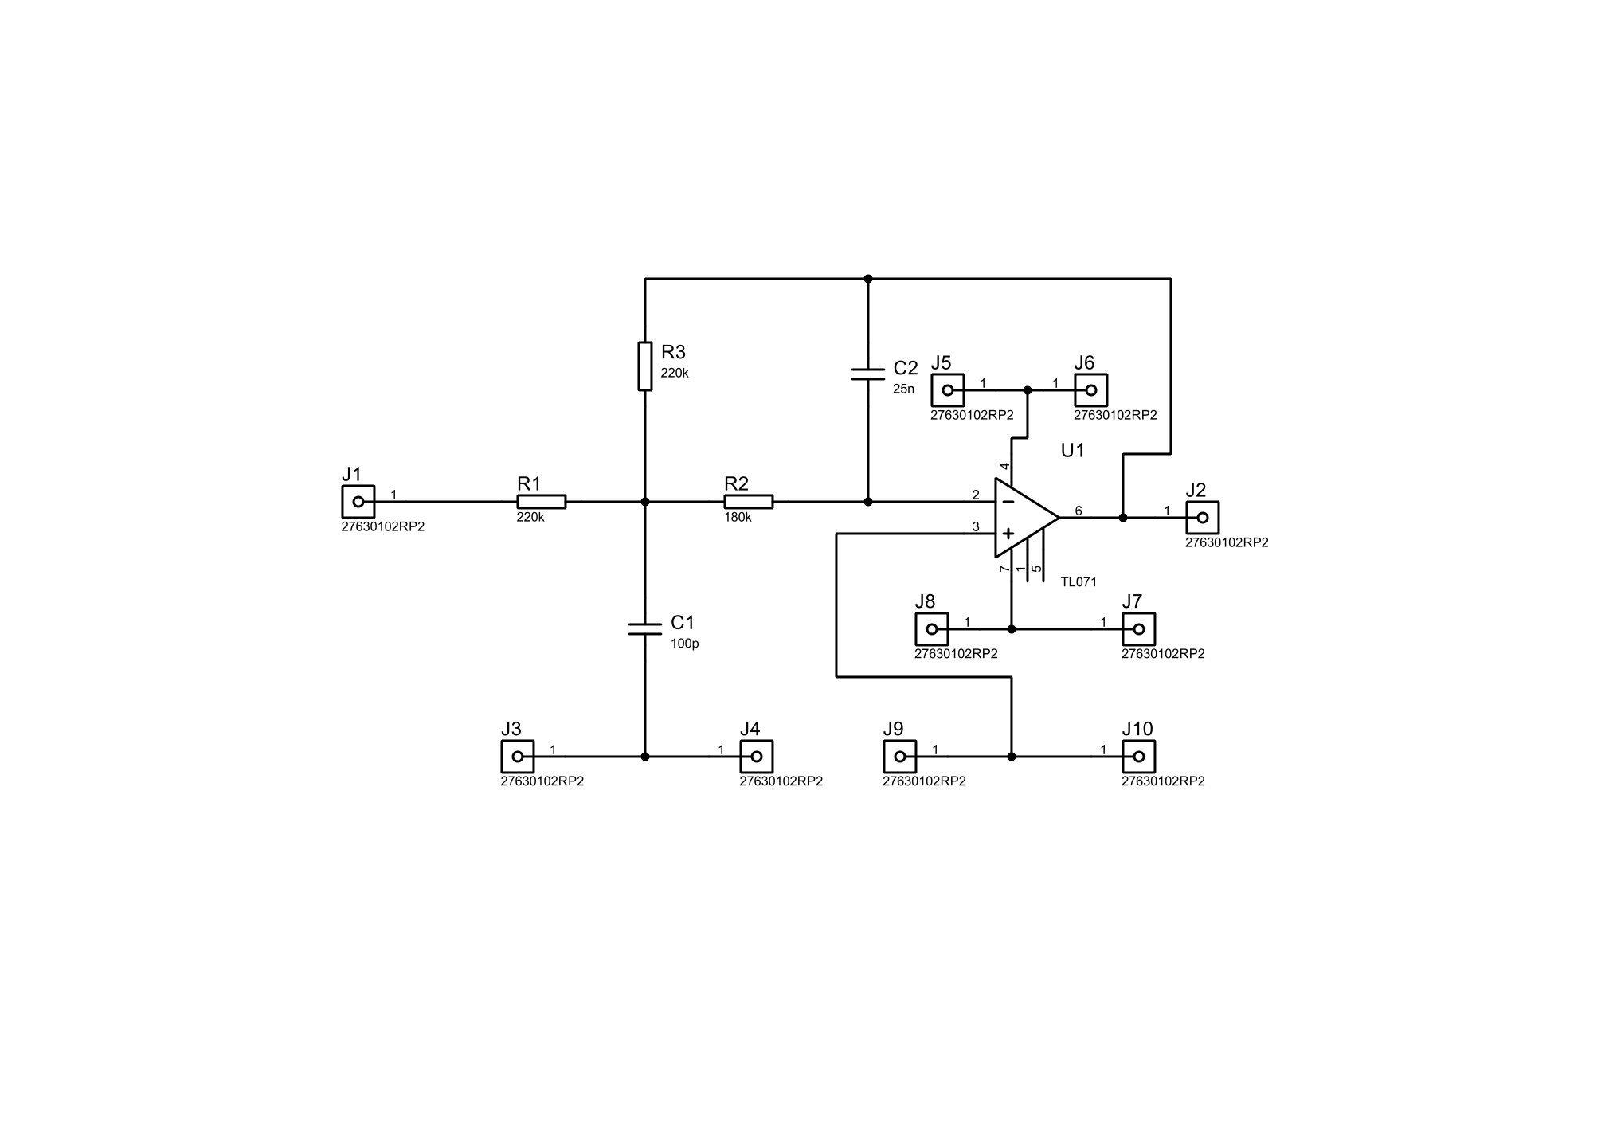

Figure 3.14 512 Hz low pass filter of EMG.

* 1. Data Acquisition System

A data acquisition system is a system that acquired or collect the data from a hardware base device and works like an interface for showing or giving a computerized output of that data.

In our project we wanted to make a data acquisition system with our trainer board to see the real-time ECG, EEG and EMG output on MATLAB so that we can further work with the collected data. For making the data acquisition system we need two parts, one is hardware part, and the second one is software part. For designing or making the data acquisition system for our Universal Trainer module we had used **Arduino Uno** as our hardware part and **MATLAB** as our software interface part.

* + 1. Designing Method of Data Acquisition System

The ECG, EEG and EMG that we were getting from our Universal Trainer Module were analog data. So first we needed to convert that analog data to a digital data through an ADQ .In our design we had used an Arduino Uno’s ADQ property as our hardware part. Secondly for interfacing or build up the communication between the hardware parts to the computer we had used the serial communication of the PC and finally using the serial communication facility of MATLAB environment we succeed to show the Real-time data on MATLAB.

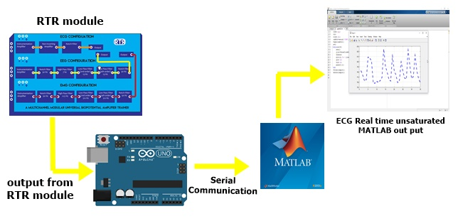

Figure 3.15 Block diagram of Data Acquisition System.

* + 1. Using Arduino Uno for Hardware Part

Arduino is an open source platform. Along with many programmable properties Arduino has analog to digital converting feature also. For our system we had used Arduino Uno.

We connected the Arduino Uno with USB cable to the PC. Then we programmed the Arduino using the IDE so that it could provide the analog input of his pic to the serial port of the PC.

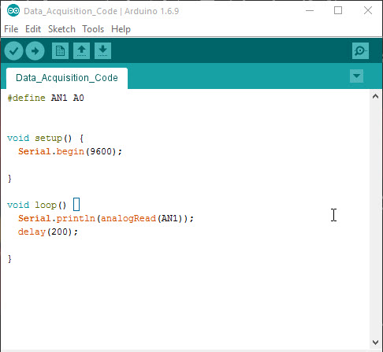

Figure 3.16 Programming of the Arduino.

Next after complaining an uploading the program to the Arduino, we set up the connection of the Arduino with the trainer board.

* We had used Arduino Uno AO pin for giving our Universal Trainer Board Output.
* We connected the power cable to Vin pin of the Arduino Uno
* Lastly we connected the ground to the Arduino Uno ground.
  + 1. Using MATLAB for Software Part

MATLAB is a high performance language for technical computing. It integrates computation, visualization and programming in an easy-to-use environment where problems and solutions are expressed in familiar mathematical notation.

For the software or Computer interfacing part we had used the MATLAB so that we can do further utilize our data. Here we had used the R2015a Version of the MATLAB.

MATLAB has serial communication property which is can be called the “comport” function in MATLAB, using that property we can call any input that was given on that

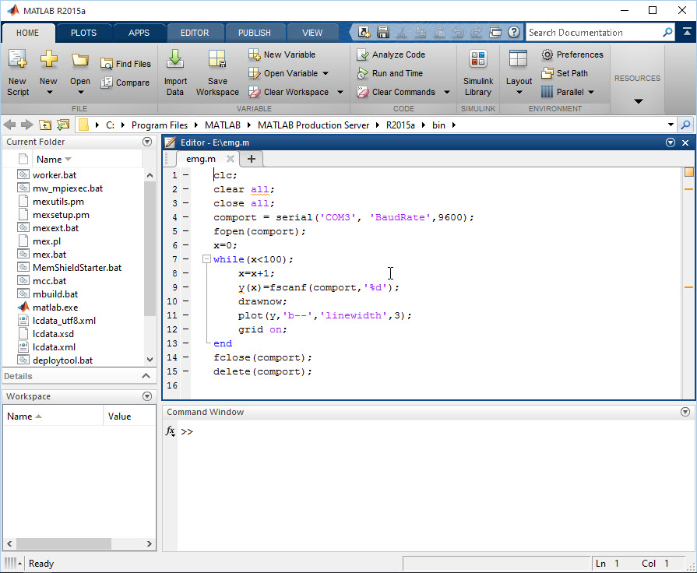

Figure 3.17 MATLAB Programming.

Serial port. Then the programming on MATLAB was done for calling the Analog input that was pass by the Arduino to the serial of the PC to get the output.

* 1. Summary

In this chapter, we tried to describe the overall instrumentation part of our project. The Universal Trainer Module contains 3 Parts ECG, EEG and EMG. Acquiring these three signals required different setups and filtering levels. Providing step to step filtering options and amplification we tried to give the trainer users a practical bio-potential device’s working experience and understanding along with the data acquisition system.

Chapter 4

Implementation

* 1. Introduction

PCB means a Printed Circuit Board. It is the board base for physically supporting and wiring the surface-mounted and socketed components in electronics. After collecting all the practical frequency responses of different components of this circuits, PCB was done for achieving the neater look of the circuit. PCB also allows easy maintenance of the circuit.

* 1. Electrocardiogram (ECG)
     1. Instrumentation Amplifier

Here is the PCB part of the instrumentation amplifier.

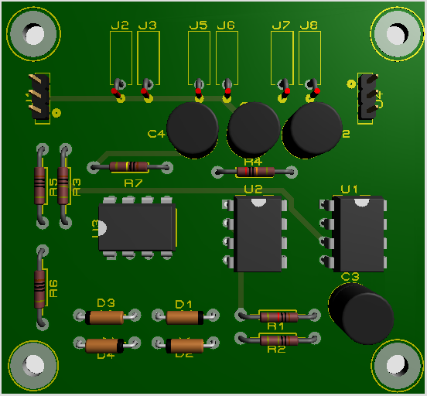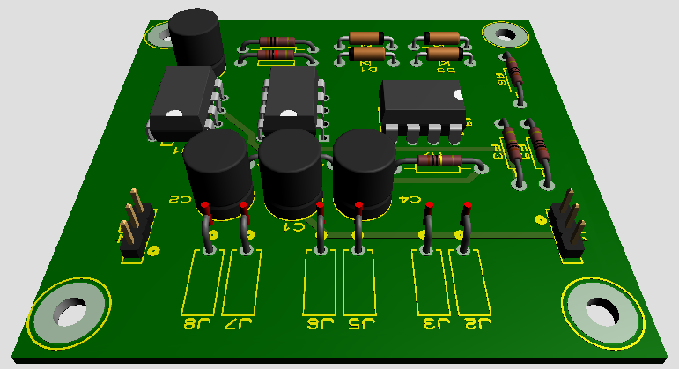

Figure 4.1 Top view of the instrumentation amplifier.

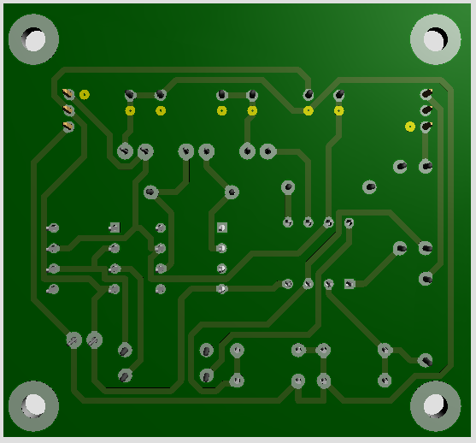

Figure 4.2 Bottom view of the instrumentation amplifier.

Here is the layout of the instrumentation amplifier.

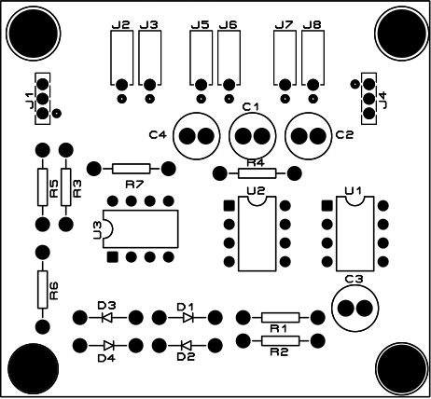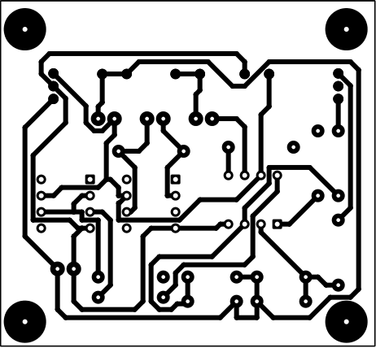

1. (b)

Figure 4.3 Top (a) & Bottom (b) view layout of instrumentation amplifier.

* + 1. Non-inverting Amplifier

Here is the PCB part of Non-inverting Amplifier.

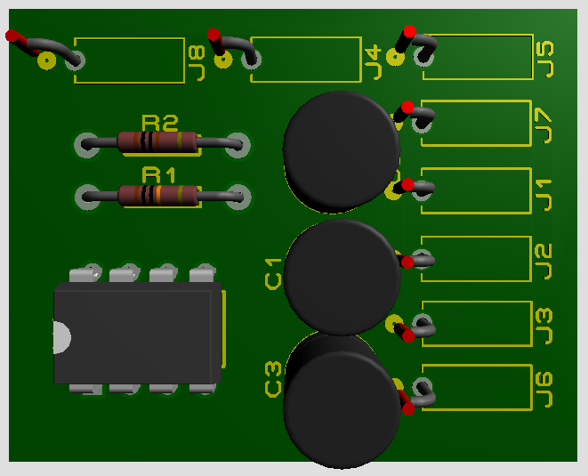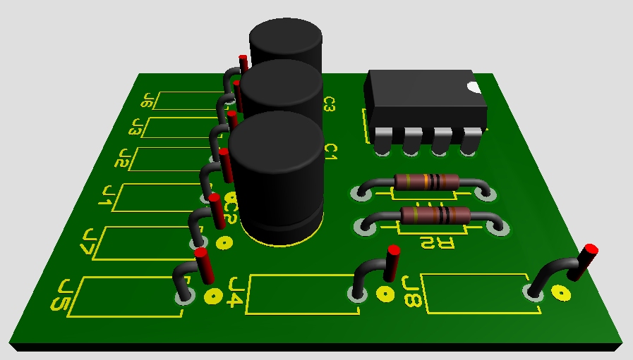

Figure 4.4 Top view of Non-instrumentation Amplifier.

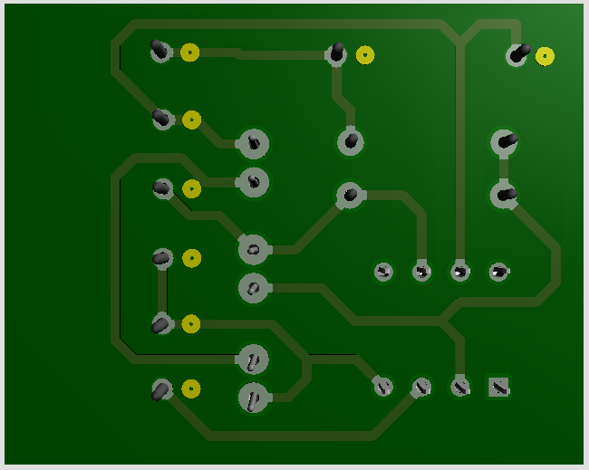

Figure 4.5 Bottom view of Non-inverting Amplifier.

Here is the layout of Non-inverting Amplifier.

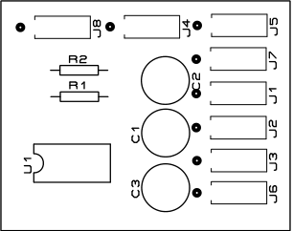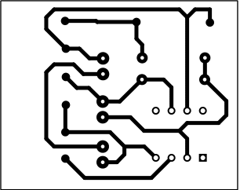

1. (b)

Figure 4.6 Top (a) & Bottom (b) view layout of the Non-inverting amplifier.

* + 1. Notch Filter

Here is the PCB part of the notch filter.

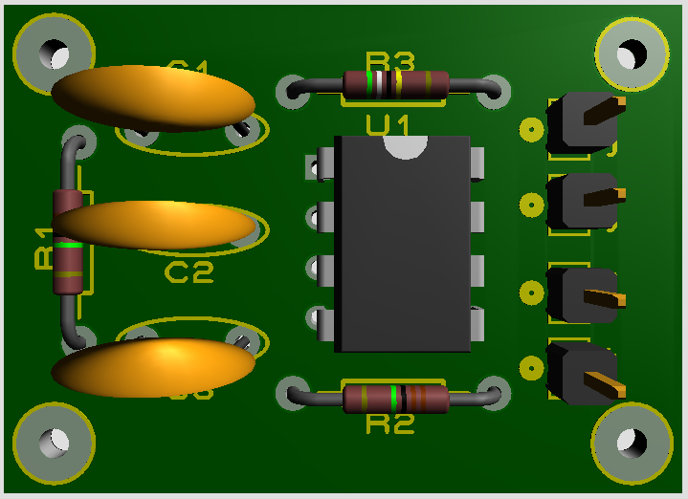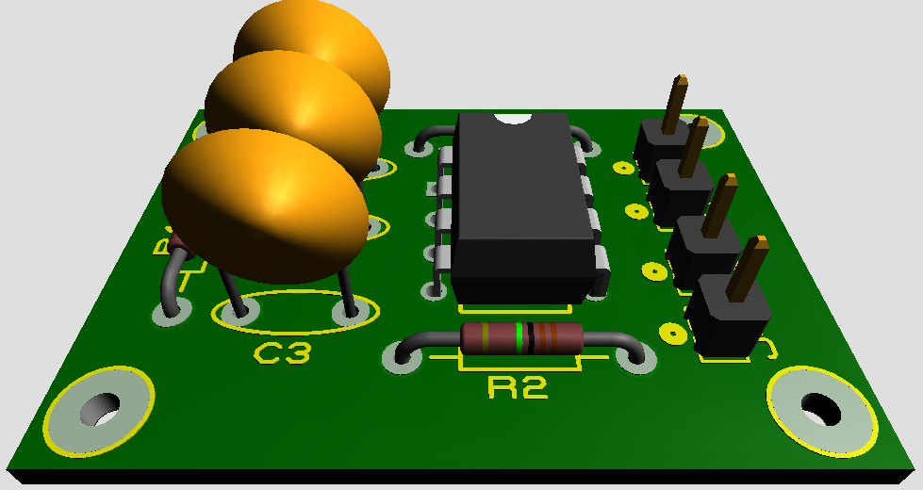

Figure 4.7 Top view of the notch filter.

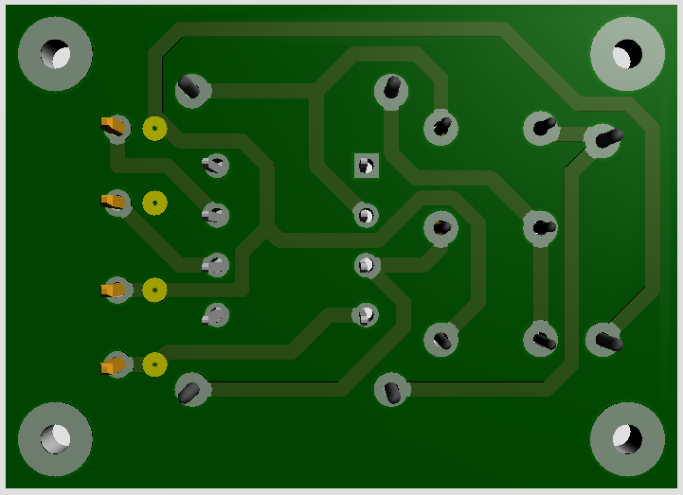

Figure 4.8 Bottom view of the notch filter.

Here is the layout of the notch filter.

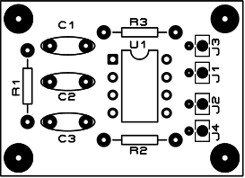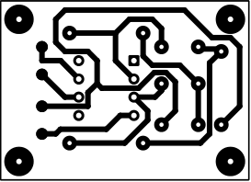

1. (b)

Figure 4.9 Top (a) & Bottom (b) view layout of the notch filter.

* 1. Electroencephalogram (EEG)
     1. Instrumentation Amplifier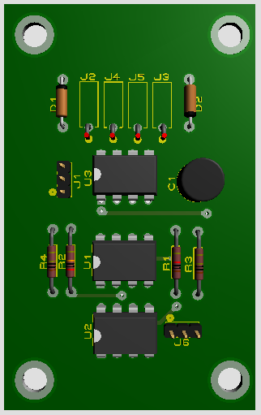

Here is the PCB and Layout of the instrumentational amplifier for electroencephalogram.

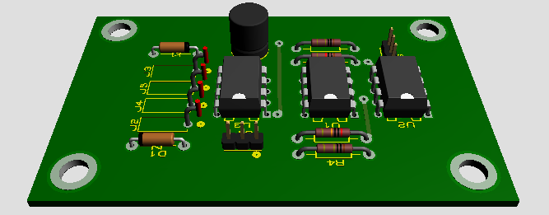

Figure 4.10 Top view of the instrumentation amplifier of EEG.



Figure 4.11 Bottom view of the instrumentation amplifier of EEG.

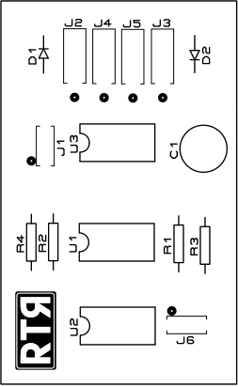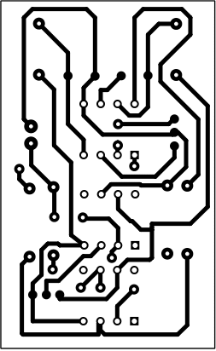

1. (b)

Figure 4.12 Top (a) & Bottom (b) view layout of the instrumentation amplifier of EEG.

* + 1. 50 Hz Notch Filter

Here is the PCB of 50Hz notch filter of the Electroencephalogram.

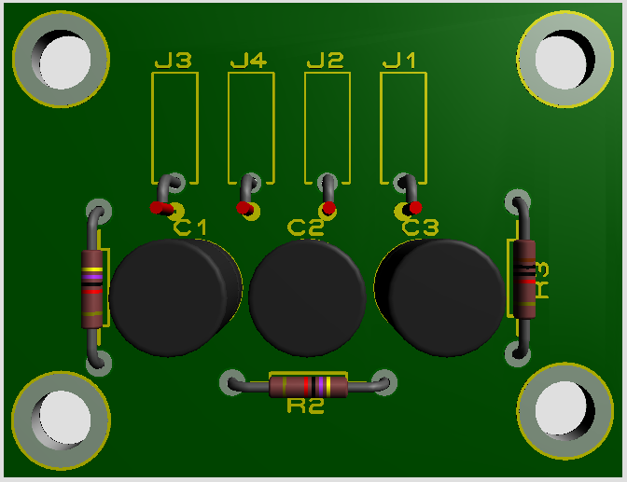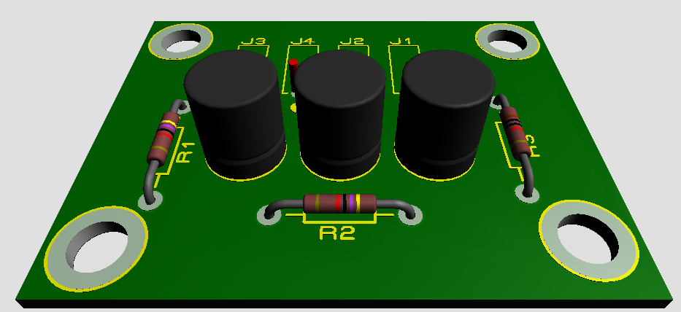

Figure 4.13 Top view of the 50Hz notch filter.

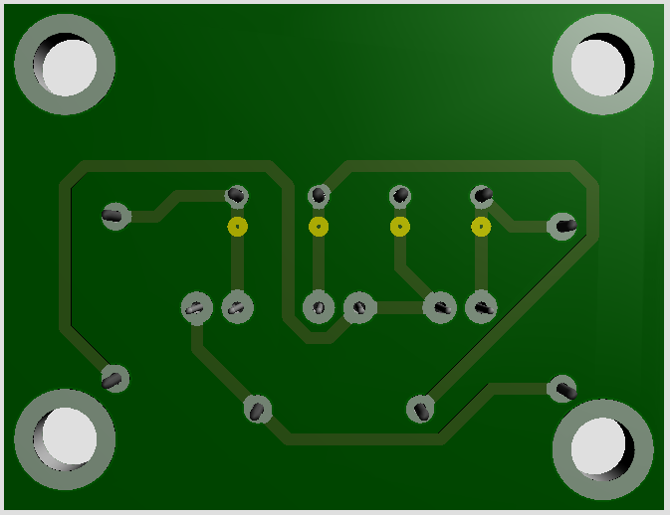

Figure 4.14 Bottom view of the 50 Hz notch filter.

Here is the layout of the 50Hz notch filter.

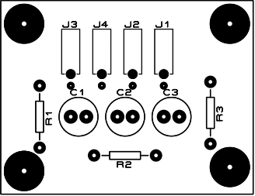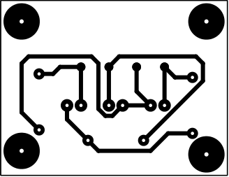

1. (b)

Figure 4.15 Top (a) & Bottom (b) view layout of the 50Hz notch filter.

* + 1. 7 Hz High Pass Filter

Here is the PCB & Layout of the 7Hz high pass filter of the Electroencephalogram.

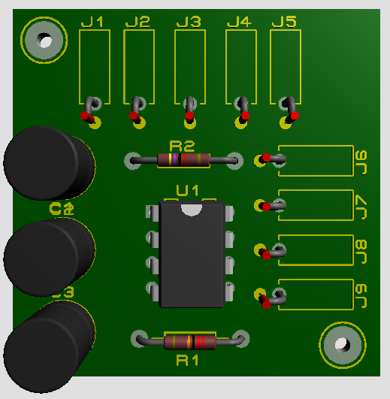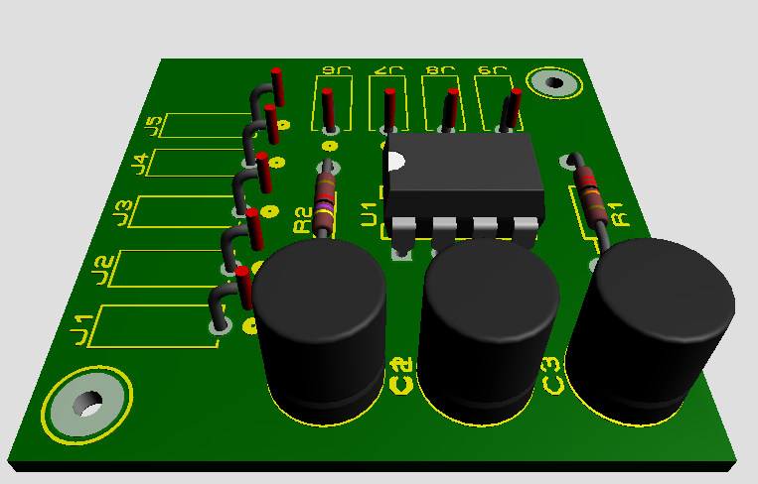

Figure 4.16 Top view of the 7Hz high pass filter.

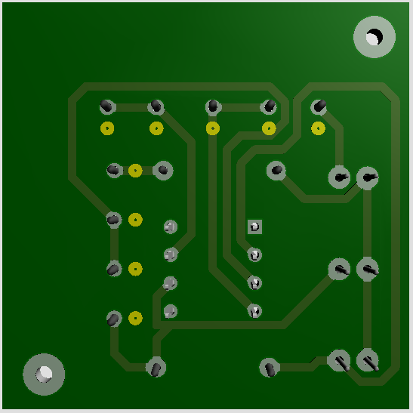

Figure 4.17 Bottom view of the 7Hz high pass filter.

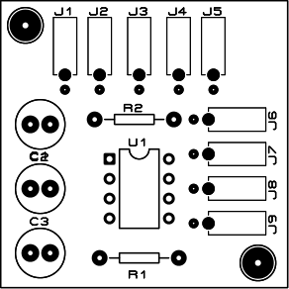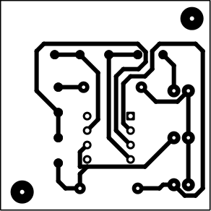

1. (b)

Figure 4.18 Top (a) & Bottom (b) view layout of the 7Hz high pass filter.

* + 1. 13 Hz Low Pass Filter

Here is the PCB & Layout of the 13Hz low pass filter of the Electroencephalogram.

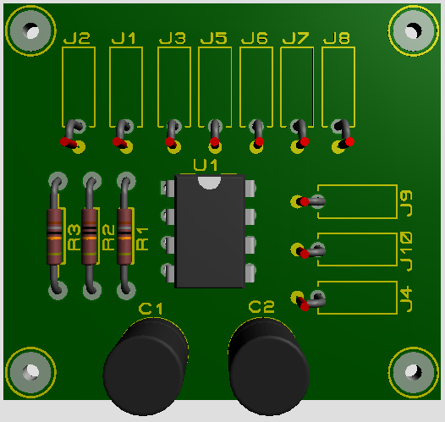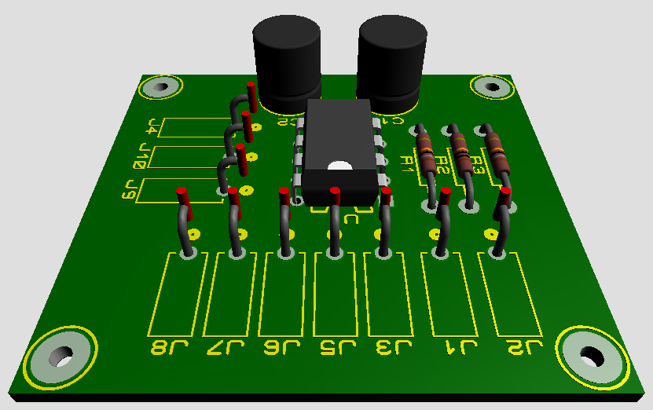

Figure 4.19 Top View of the 13Hz low pass filter.

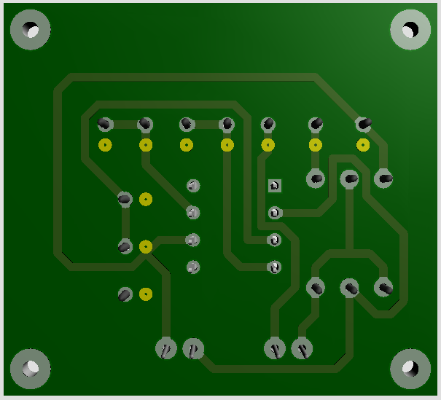

Figure 4.20 Bottom view of the 13Hz low pass filter.

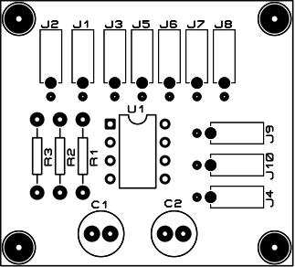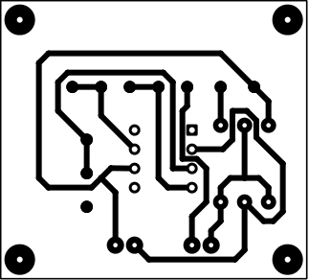

1. (b)

Figure 4.21 Top (a) & Bottom (b) view layout of the 13Hz low pass filter.

* 1. Electromyogram (EEG)
     1. Instrumentation Amplifier

Here is the PCB and Layout of the instrumentational amplifier for electromyogram.



Figure 4.22 Top view of instrumentational amplifier for EMG.

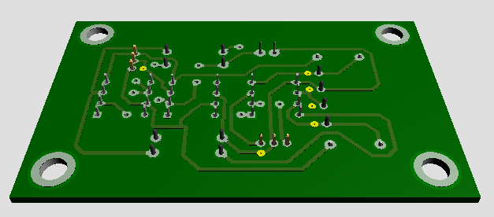

Figure 4.23 Bottom view of instrumentational amplifier for EMG.

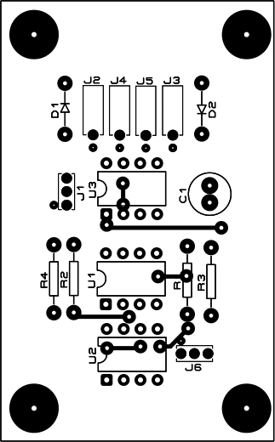

Figure 4.24 Top view layout of instrumentational amplifier of EMG.

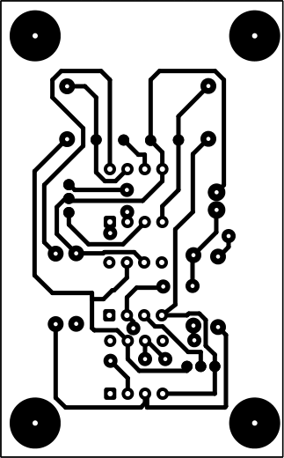

Figure 4.25 Bottom view layout of the instrumentation amplifier of EMG.

* + 1. Notch Filter

PCB of the Notch Filter of EMG is the same PCB design of the EEG which was described before in 4.3.3.

* + 1. 7 Hz High Pass Filter

PCB of the 7 Hz high pass filter of EMG is the same PCB design of the EEG which was described before in 4.3.3.

* + 1. 512 Hz Low Pass Filter

PCB of the 512 Hz high pass filter of the EMG was the same PCB design of 13 Hz low pass filter of the EEG which was described before in 4.3.4.

* 1. Prototype of RTR Module

Here is the Design Prototype of Proposed RTR module.

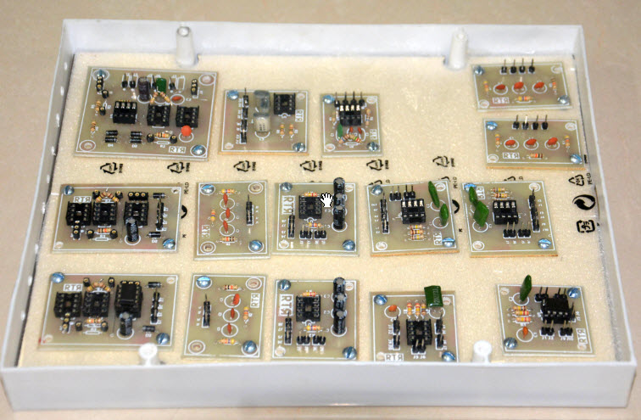

1. Circuit Blocks.

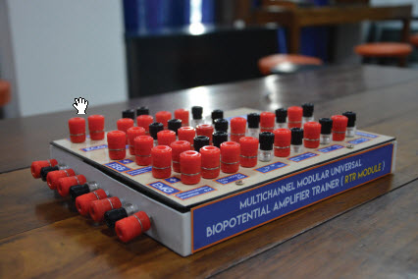

(b) Side view.

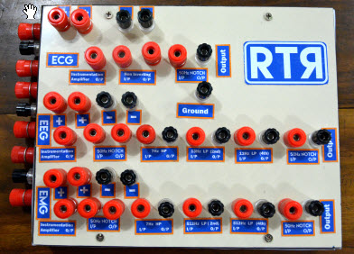

(c) Front view.

Figure 4.26 Designed Prototype of Multichannel Modular Universal Biopotential Amplifier Trainer or RTR Module.

* 1. Summary

In this chapter, the Layout and PCB of the circuit were shown. Different kind of filtering parts layout and PCB are shown in this section. Later the modular board of a multichannel modular universal biopotential amplifier trainer was shown.

Chapter 5

Results & Measurements

* 1. Introduction

In this chapter waveforms from the imported EEG, EEG and EMG modules and our Universal module were recorded and shown. Results from the imported modules and our Universal module were analyzed and compared also.

* 1. Output

In the laboratory we had tested our ECG, EEG and EMG part of our Universal Module several times. The experiment with the human body biopotential signal measurements, Ag/AgCl surface electrodes ( $E_{a,}E_{b and }E_{ref,}$) were used and ECG, EEG and EMG were recorded. The bioamplifier module connection configuration for the measurement of ECG, EEG and EMG were given in figure 5.1.

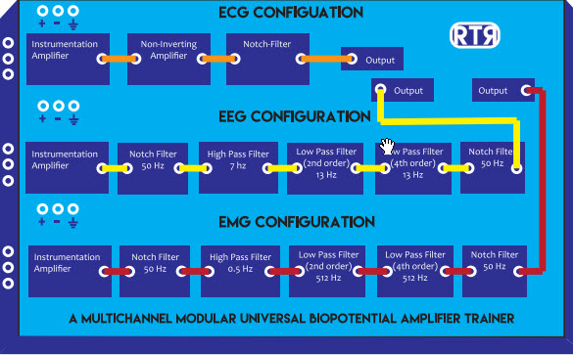

Figure 5.1 RTR module configuration for different experiment configuration.

* + 1. ECG Module Output

With the human body experiments, first we discussed the ECG experiment. For the placement of the lead we used bipolar lead configuration, where two measurement electrodes are attached to the right and left arms, respectively. Reference electrode is placed in the right lag. Figure 5.2(a) shows the placement of electrodes and figure 5.2(b) shows experimental result.

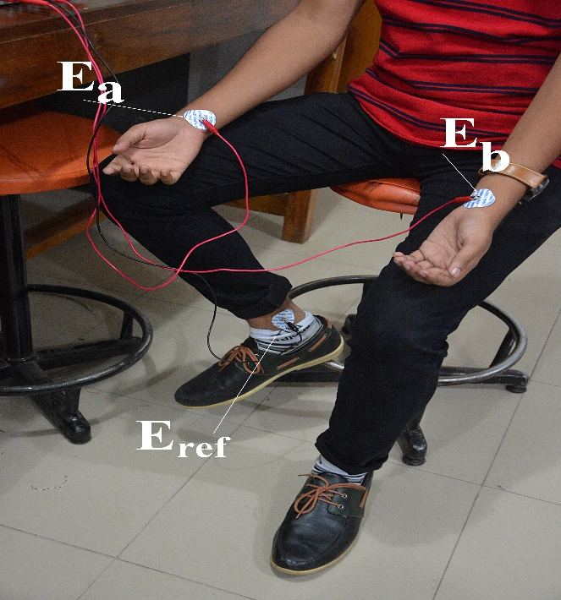

(a)

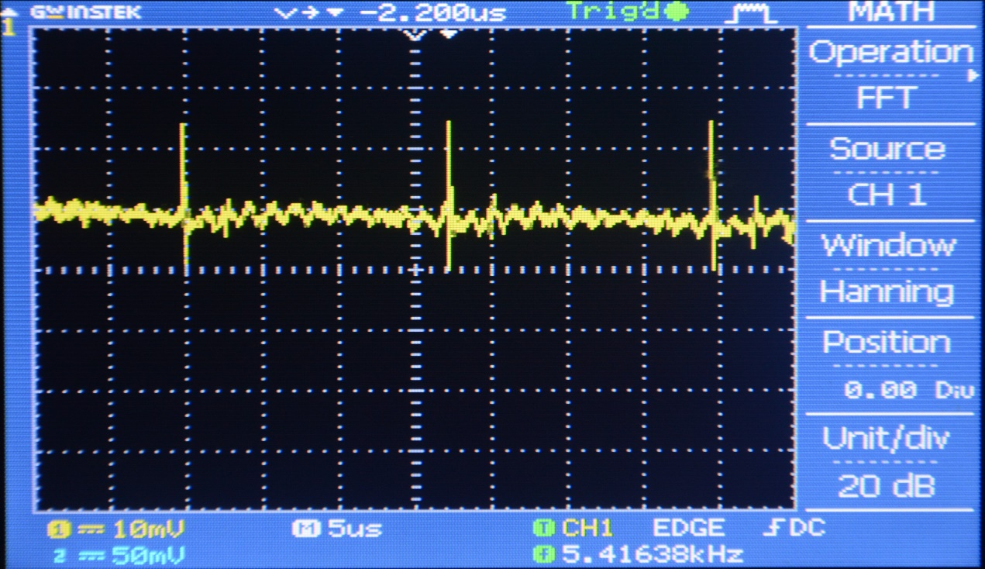

(b)

Figure 5.2 ECG measurement. (a) Electrode measurement. (b) ECG output.

In the figure 5.2(b), QRS complex was recognized along with the t wave. Also shown a continuous ECG Signal.

* + 1. EEG Module Output

For the EEG measurement experiment the module connection configuration is given in fig 5.1. Our EEG module basically targeted to acquire the alpha range of the EEG signal which can be absorbed perfectly when the eyes are closed. Two measurement electrodes were placed on right and left side of our forehead just above the eye, respectively. The placement of the electrodes and experimental result are shown in fig 5.3.

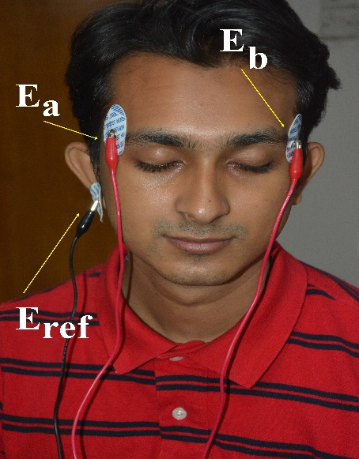

(a)

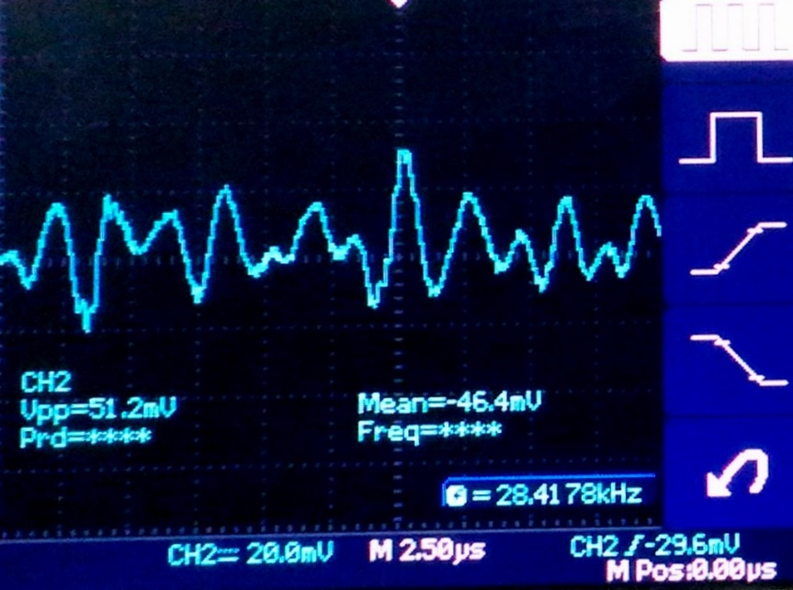

(b)

Figure 5.3 EEG measurement. (a) Electrode measurement. (b) EEG output.

The EEG output showed only the Alpha signals.

* + 1. EMG Module Output

Finally the EMG measurement experiment is done. For measuring the EMG signal the bioamplifier module connection configuration is shown in Fig 5.1 .For the EMG measurement electrodes are placed on the skin surface of the forearm flexor muscle, and reference electrode were is placed below the elbow. Below the elbow was taken as a ground because there is no muscle but it’s a bone surface. The placement of the electrodes and experimental result are shown in fig 5.4.

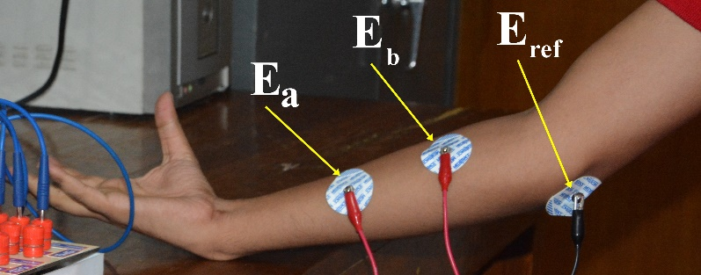  
(a)

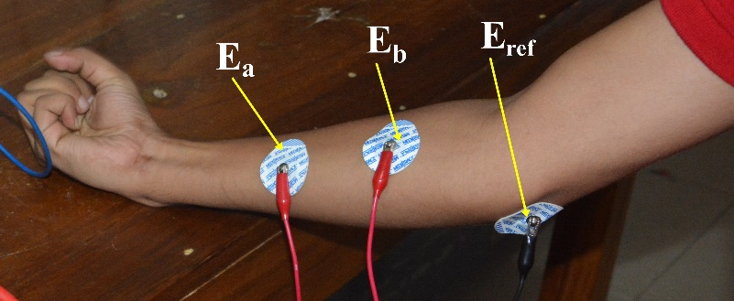  
(b)

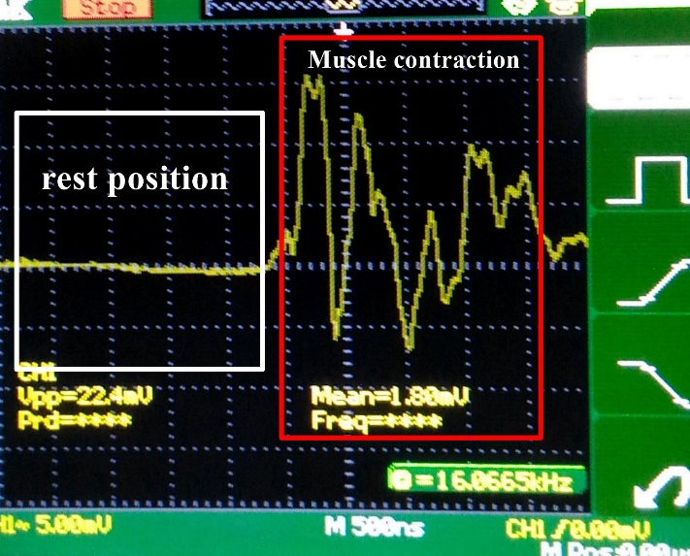  
(c)

Figure 5.4 EMG measurement. (a) Rest position. (b) Muscle contraction. (c) EMG output.

* 1. Summary

We have tasted our RTR module and measured the desired biopotentials from a healthy human object. All those ECG, EEG and EMG were recorded prior to signal processing in MATLAB. These pre-signal processed outputs have noise within it which are mostly, environmental noise, power-line interference and electrode contact errors. These noises and errors can be eliminated further through signal processing in MATLAB. However, the pre-signal processed outputs that we got from our experimental measurements were suitable enough and acceptable for further signal processing and acquisition.

Chapter 6

Discussions and Conclusions

* 1. Discussion

In circuit construction components like capacitors, resistors have to be exactly same as equations. If exact valued components were not used the desired values, frequency range, cut-off frequency and gain will be changed. Hence the output will be changed. The op-amps with the same model number but manufactured in different facilities usually have different pin numbers. This should be checked before implementing the circuit. Noise free cables must be used to document input and output curves. Electrodes used to acquire neural waves or brain waves or muscle waves have to be noise-free and high quality with proper conductivity. Otherwise, simple disturbance of the cable and also interference of different frequencies may cause noise output. Electrode should be in linear, not twisted. If it is twisted, it may cause noise output. There should be no gap between skin and electrodes, rather it may cause illogical output.

In this project, we have tried to implement a study purpose modular board which includes all the three (ECG ,EEG , EMG) circuits in one place with s different stage of filtering. So the student can easily check his or her neural waves, brain waves and muscle waves. From this, they will be motivated to explore some new ideas. From the different stages of filtering, the student can analysis his or her data in Matlab. By analyzing data student will learn about the proper knowledge of ECG or EEG or EMG. Data acquisition system is the step of processing the raw data to digital data. By receiving the digital data, the data can be shown in Matlab for further analysis.

* 1. Limitation Of the Project

There are some limitations in this project. Such as:

* Many abnormal patterns on an ECG or EEG or EMG may be non-specific, meaning that they may be observed with a verity of different conditions. They may be a normal variant and not reflect any abnormality at all.
* Environmental signal, meaning that signal from other electrical parts can be a cause of getting imperfect waveform from the modular device.
  1. Conclusions

The proposed Universal biopotential amplifier trainer aimed to be compact educational tool for the students and laboratory experiments. We designed the board in a manner that the students can configure the board to develop hand-on skills and learn step by step procedure of biopotential amplification. The developed trainer is a cost effective compact educational tool with limited features to get basic biopotential signals of ECG, EEG and EMG. In the future, this educational Universal biopotential amplifier trainer board can be improved for measurements of author biopotential activities by adding more sensing and filtering blocks or modules.

REFERENCES

1. L. A. K, "The web’s where you study in!," 2008. [Online]. Available: http://www.ustudy.in/node/5029. Accessed: Jul. 24, 2016.
2. Farlex, "Bioamplifier," TheFreeDictionary.com, 2003. [Online]. Available: http://encyclopedia.thefreedictionary.com/bioamplifier. Accessed: Jul. 24, 2016.
3. N. Instruments, "What is data acquisition? - national instruments," 2009. [Online]. Available: http://www.ni.com/data-acquisition/what-is/. Accessed: Jul. 24, 2016.
4. Contributors, "What is an Arduino?,". [Online]. Available: https://learn.sparkfun.com/tutorials/what-is-an-arduino. Accessed: Jul. 24, 2016.
5. "Werkstatt workshop,". [Online]. Available: http://www.werkstattworkshop.com/?q=arduino. Accessed: Jul. 24, 2016.
6. "Welcome to the SERC Webpage. For the academic department, visit CDS.IISc.in,". [Online]. Available: http://www.serc.iisc.in/facilities/matlab-8-6-r2015b/. Accessed: Jul. 24, 2016.
7. Macfarlane PW, Lawrie TDV (eds.) (1989): “Comprehensive Electrocardiology: Theory and Practice in  
   Health and Disease”, 1st ed., Vol. 1, 2, and 3, 1785 pp. Pergamon Press, New York.
8. Nelson CV, Geselowitz DB (eds.) (1976): “The Theoretical Basis of Electrocardiology”, 544 pp. Oxford  
   University Press, Oxford.
9. "Cardiac Muscle Fibers". ZY 560 Mammalian Physiology. Auburn University. Retrieved January 2, 2015
10. Zhao, Z.D., Chen, Y.Q.: A new method for removal of baselinewander and power line interference in ECG signals. In: Proceedings of the Fifth International Conference on Machine learning and cybernetics, pp.4342–4347 (2206)
11. "Coronary heart disease in Bangladesh," World Life Expectancy, 2014. [Online]. Available: http://www.worldlifeexpectancy.com/bangladesh-coronary-heart-disease. Accessed: Jul. 24, 2016.
12. Sornmo, L.; Laguna, P.: Bioelectrical Signal Processing in Cardiacand neurological processing. Elsevier Academic Press, Amsterdam. ISBN-13: 978-0-12-437552-9 (2005)
13. S. thapa, "Butterworth filter design and low pass Butterworth filters," Basic Electronics Tutorials, 2013. [Online]. Available: http://www.electronicstutorials.ws/filter/filter_8.html. Accessed: Jul. 24, 2016.
14. In Wireless Engineer (also called Experimental Wireless and the Wireless Engineer), vol. 7, 1930, pp.536–541 - "On the Theory of Filter Amplifiers"-S. Butterworth
15. K. BlockaMedically, "EEG (Electroencephalogram)," Healthline, 2005. [Online]. Available: http://www.healthline.com/health/eeg#Overview1. Accessed: Jul. 25, 2016.
16. Jaakko Malmivuo and Robert, *Bioelectromagnetism*. New York: Oxford University Press, 1995. [Online]. Available: http://www.bem.fi/book/index.htm. Accessed: Jul. 25, 2016.
17. "File: HansBerger Univ Jena.jpeg - Wikimedia commons," 1941. [Online]. Available: https://commons.wikimedia.org/wiki/File%3AHansBerger_Univ_Jena.jpeg. Accessed: Jul. 25, 2016.
18. H. Berger, "Über das Elektrenkephalogramm des Menschen," *Archiv für Psychiatrie und Nervenkrankheiten*, vol. 87, no. 1, pp. 527–570, Dec. 1929.
19. S. thapa, "Butterworth filter design and low pass Butterworth filters," Basic Electronics Tutorials, 2013. [Online]. Available: http://www.electronics-tutorials.ws/filter/filter_8.html. Accessed: Jul. 25, 2016.
20. Vassalle, M. (1977). "The relationship among cardiac pacemakers: Overdrive suppression". Circulation Research 41 (3): 269–77. doi:10.1161/01.res.41.3.269. PMID 330018.
21. "EEG,". [Online]. Available: http://www.medicine.mcgill.ca/physio/vlab/biomed_signals/eeg_n.htm. Accessed: Jul. 25, 2016.
22. 3 C. D. Browser, "Human head 3D model Download," 2007. [Online]. Available: http://www.3dcadbrowser.com/download.aspx?3dmodel=5534. Accessed: Jul. 25, 2016.
23. "Home," Noraxon USA. [Online]. Available: http://www.noraxon.com/?smd_process...1. Accessed: Jul. 25, 2016.
24. "Carlo Matteucci," Wikiwand. [Online]. Available: http://www.wikiwand.com/it/Carlo_Matteucci. Accessed: Jul. 25, 2016.
25. "What is an EMG,". [Online]. Available: http://smpp.northwestern.edu/bmec66/weightlifting/emgback.html. Accessed: Jul. 25, 2016.
26. "History of EMG,". [Online]. Available: https://publish.illinois.edu/bmesemgveeg/history-of-emg/. Accessed: Jul. 25, 2016.
27. Themes and C. ·Back, "Bio-potential measurement basics," PlayRobots, 2016. [Online]. Available: http://www.playrobots.co.uk/projects/bio-potential-monitoring/bio-potential-measurement-basics/. Accessed: Jul. 25, 2016.
28. E. language ® America, "Bioamplifier,". [Online]. Available: http://america.pink/bioamplifier_670981.html. Accessed: Jul. 25, 2016.
29. "Isolated bio-amplifier with active probe,". [Online]. Available: https://www.wpiinc.com/products/physiology/iso-80-isolated-bio-amplifier-with-active-probe/. Accessed: Jul. 25, 2016.
30. [Online]. Available: https://www.biopac.com/. Accessed: Jul. 25, 2016.
31. BiBeat, "12 lead ECG," BiBeat, 2013. [Online]. Available: https://bibeat.com/product/12-lead-ecg/. Accessed: Jul. 25, 2016.
32. BiBeat, "NCV-EMG," BiBeat, 2015. [Online]. Available: https://bibeat.com/product/ncv-emg/. Accessed: Jul. 25, 2016.
33. O. O. Store, "R&D kit (16-channel) — 32bit, daisy, & accessories," OpenBCI Online Store, 2016. [Online]. Available: http://shop.openbci.com/collections/frontpage/products/openbci-16-channel-r-d-kit?variant=785215991. Accessed: Jul. 25, 2016.
34. M. E. Ltd, "Pioneers in Biosignal monitoring technology," 2016. [Online]. Available: http://www.megaemg.com/. Accessed: Jul. 25, 2016.
35. M. E. Ltd, "Mega electronics Ltd," 2016. [Online]. Available: http://www.megaemg.com/products/neurone-eeg-system/?GTTabs=3. Accessed: Jul. 25, 2016.
36. "News & analysis," 2016. [Online]. Available: http://www.globalspec.com/learnmore/data_acquisition_signal_conditioning/signal_conditioning/instrumentation_amplifiers. Accessed: Jul. 25, 2016.
37. hira awan, "Non-inverting operational amplifier - the Non-inverting op-amp," Basic Electronics Tutorials, 2013. [Online]. Available: http://www.electronics-tutorials.ws/opamp/opamp_3.html. Accessed: Jul. 25, 2016.
38. "Non-Inverting amplifier," Google+. [Online]. Available: http://www.radio-electronics.com/info/circuits/opamp_non_inverting/op_amp_non-inverting.php. Accessed: Jul. 25, 2016.
39. Farlex, "Notch filter," TheFreeDictionary.com, 2003. [Online]. Available: http://encyclopedia2.thefreedictionary.com/notch+filter. Accessed: Jul. 25, 2016.
40. abubakar murtala, "Low pass filter - passive RC filter Tutorial," Basic Electronics Tutorials, 2013. [Online]. Available: http://www.electronics-tutorials.ws/filter/filter_2.html. Accessed: Jul. 25, 2016.
41. "Low pass filter- explained,". [Online]. Available: http://www.learningaboutelectronics.com/Articles/Low-pass-filter.php. Accessed: Jul. 25, 2016.
42. "High pass filter- explained,". [Online]. Available: http://www.learningaboutelectronics.com/Articles/High-pass-filter.php. Accessed: Jul. 25, 2016.
43. T. MathWorks, "MathWorks – makers of MATLAB and Simulink - MathWorks United Kingdom," 1994. [Online]. Available: http://www.mathworks.com/index.html?s_tid=gn_logo. Accessed: Jul. 27, 2016.
44. "The Biosignal how-to [BPM biosignals]," Google+, 2014. [Online]. Available: http://biosignals.berndporr.me.uk/doku.php?id=start. Accessed: Jul. 27, 2016.

Appendix A

Arduino Code

#define AN1 A0

void setup() {

Serial.begin(9600);

}

void loop() {

Serial.println(analogRead(AN1));

delay(200);

}

MATLAB Code

clc;

clear all;

close all;

comport = serial('COM3', 'BaudRate',9600);

fopen(comport);

x=0;

while(x<100);

x=x+1;

y(x)=fscanf(comport,'%d');

drawnow;

plot(y,'b--','linewidth',3);

grid on;

end

fclose(comport);

delete(comport);

Appendix B

Datasheet of the Chips used in the circuit

